Chapter 1
Company Profile

Introduction
Located in Bareilly and established in 2008, we are a premier institute dedicated to empowering individuals through cutting-edge training in various disciplines. Whether you’re looking to enhance your skills in Computer Science, IT, Office Automation, Data Science, Artificial Intelligence, Machine Learning, Robotics, Blockchain, Graphic Design, or Animation, we have the perfect course tailored to meet your needs.

1.2. Vision & Mission
Our vision at Techvision Technologies is to emerge as the foremost IT training company, delivering unparalleled education, and training to professionals worldwide. We aim to redefine the landscape of IT training, perpetually innovating across various courses, learning modes, and delivery methodologies.

At the core of our mission is the creation of a dynamic community comprising avid learners, seasoned trainers, and industry experts who share an unwavering passion for their careers. We are dedicated to arming our students with the expertise and knowledge required to emerge as industry trailblazers, propelling innovation and fostering growth in the IT sector.
Our overarching mission is to empower professionals with a tailored blend of skills and knowledge essential for their career triumphs. We are steadfast in our commitment to
    - Providing cutting-edge training and development programs meticulously tailored to cater to the distinctive needs of our learners.
    - Furnishing practical skills and immersive hands-on experiences that empower our students with the unwavering confidence to confront real-world challenges head-on.

1.3. Training & Certifications Programs

Techvision Technologies offers a diverse array of training and certification programs catering to both engineering students and professionals. Some of our prominent programs includes.

- Full Stack Development- Techvision offers the full stack program for web development and provide the experienced team member for our learning.

- Database Management- Techvision gives the knowledge about how to handle the different queries of the database and manage the data efficiently.

1.4. Training Approach & Methodology

Techvision Technologies champions a student-centric approach underpinned by a tailored methodology for its training programs. Here are some of the hallmark features of our training approach and methodology-

- Diverse Training Programs: We offer an array of training programs designed to cater to varying levels of students. These encompass 2/3/4/6-week training modules, industrial training, winter training, college campus training, and more, ensuring that each student's unique needs are met.
- Extensive Technologies Coverage: Our comprehensive training curriculum encompasses over 50 leading technologies and software programs, spanning diverse domains such as cloud computing, Java, MERN, Data Science, Artificial Intelligence and many more .

- Practical Learning: Our training sessions are characterized by hands-on practical sessions, live project experiences, interactive workshops, and informative seminars. These elements collectively enhance the practical skills and knowledge base of our students, fostering a holistic learning experience.

- Certifications and Support: Upon successful completion of our training programs, students receive industry-recognized certificates that bolster their credentials. Additionally, we extend placement assistance and consultancy services, empowering students to embark on their professional journeys with confidence.

Chapter 2
Industry at a Glance
Techvision Technologies is a well-regarded company specializing in engineering training for both students and professionals. In addition to the educational services, they excel in offering comprehensive solutions, including software development, mobile application development, digital marketing, mechanical design, and advanced chip development services. Notably, they have a track record of successfully placing students into multinational corporations (MNCs) within a year, underscoring their commitment to talent development and career advancement.

2.1. Training and Development Department

Techvision Technologies Training & Development Department excels in providing real-time training in cutting-edge engineering domains like AWS, DevOps, and Full stack development. Our diverse training programs, including summer, winter, regular, and corporate options, enhance both technical and soft skills. We also offer comprehensive placement assistance to help trainees secure positions in top-tier IT companies. Techvision Technologies, are dedicated to empowering individuals for success in the ever-evolving tech industry.

2.2. Best College Campus Training

The College Campus Training Program, an integral initiative within Techvision Technologies, represents a comprehensive endeavor aimed at equipping engineering students with cutting- edge technological knowledge within the confines of their college campuses. This program caters to a diverse array of students, including those pursuing B.Tech/M.Tech, B.SC/M.SC, BCA/MCA degrees, and more, with a deep-seated recognition of the paramount importance of practical training over theoretical knowledge in the demanding corporate landscape. Techvision Technologies, an eminent Technologies Promotion Association.
At Techvision Technologies, our College Campus Training is meticulously architected to elevate students' "industry readiness", making them exceptionally employable upon their academic journey's culmination. This program envelops an extensive spectrum of technological domains and is made accessible at a reasonable fee structure. During the training immersion, students are

the beneficiaries of a harmonious blend of theoretical acumen and hands-on experiential learning, often culminating in the completion of a substantive project of significance. To facilitate this holistic learning odyssey, we provide comprehensive study materials and state-of-the-art lab resources. Following the triumphant completion of the program, students are bestowed with globally recognized certificates of accomplishment.

The on-campus training program confers multifaceted benefits upon both the students and college authorities alike. It optimally allocates students' financial resources by providing cost- effective training avenues vis-a-vis traditional off-campus alternatives. This remarkable flexibility empowers students to embark on 2-4-week training journeys, thus ensuring the comprehensive coverage of academic syllabus content while meticulously adhering to the exalted quality standards for which Techvision Technologies is celebrated.

In essence, on-campus training transcends mere conceptual premise, serving as an immersive portal into the professional realm, whose practical skills and applied knowledge reign supreme. These distinguished courses, conducted within the academic bastions themselves, feature the guidance and expertise of dedicated professionals from Techvision Technologies, who bestow knowledge and inspiration through intensive five to six-hour daily sessions. This training regimen encompasses not only technical proficiencies but also the crucial soft skills that empower students for a triumphant transition into the dynamic and competitive corporate sphere. Our fervent mentors, frequently emerging engineers from the industry's vanguard, sustain a culture of engagement and unwavering focus, this by ensuring a profoundly transformative learning experience.

2.3. Fresher Training

If you are a recent graduate or a final-year student eager to embark on an enriching journey of long-term industrial training, summer training, winter training, or a concise 6-week training program, Techvision Technologies stands as the ideal choice for you. Techvision is a premier training company renowned for its commitment to nurturing engineering students in various northern cities of India, including Roorkee, Noida, Lucknow, and Dehradun. What sets Techvision apart is its assembly of highly proficient and promising experts who employ an elite training methodology, solidifying Techvision Technologies reputation as the preeminent summer training institute in the Delhi NCR region.

Our fresher training programs at Techvision Technologies are characterized by an immersive, hands-on approach. These programs hold immense value for scholars who have recently completed their degree programs. Fresher training serves as a bridge between academic knowledge and real-world industry applications, which is of paramount importance for engineering students. Techvision Technologies tailors fresher training across a wide spectrum of engineering disciplines, equipping students with essential employability skills that complement their academic coursework. We understand the significance of this transitional phase, and our training is meticulously designed to empower students for successful career integration.

2.4. Industrial Training

Embark on a Transformative Journey with Techvision Technologies 45 Days Industrial Training Program in Bareilly. Techvision Technologies, a paragon of excellence in industrial training, offers a comprehensive learning experience tailored as per the Unique requirements of aspiring the CS/CSE/IT/ BCA/MCA /B.Tech/M.Tech /B.SC/M.SC /BE/Engineering students.
The compelling rational under pinning the indispensability of our six-month industrial training program for budding engineers lies in its ability to meticulously groom them for the dynamic demands of the corporate world. This immersive training regimen serves as a conduit, introducing students to the intricate tapestry of real-world industry operations. It fosters unwavering self-assurance while unearthing and honing their innate strengths. Beyond bolstering self-confidence, it nurtures leadership acumen and a profound sense of responsibility, ensuring adeptness in the execution of tasks. furthermore, it serves as an academic bridge, connecting theoretical concepts to tangible, hands-on applications within an authentic job environment.

At Techvision Technologies, an unrivalled Industrial Training Centre catering to the diverse spectrum of B.Tech/CS/CSE/IT/BCA/MCA/BE/M.Tech/B.SC/M.SC students, we have set the bar for excellence. Our program seamlessly interlaces cutting-edge theoretical knowledge with practical hands-on experiences in the latest technologies.

As a prominent Industrial Training Institute for BE/Computer Science/IT/ BCA/MCA/B.SC/M.SC/B.Tech/M.Tech. Techvision Technologies extends its expertise to both students and corporate entities. In addition to imparting knowledge, we offer placement services, this by propelling fresh graduates into the professional realm.

The profound significance of our six-month industrial training in Bareilly lies in its pivotal role in bridging the chasm between theoretical knowledge and pragmatic implementation, an imperative into day's fiercely competitive corporate landscape. Training at the zenith Industrial Training CS/CSE/IT/BCA/MCA /B.Tech/M.Tech /B.SC/M.SC/BE/Engineering aspirants provides a fertile ground for applying abstract theoretical constructs to real-world projects. Our 45 days Industrial Training Program encompasses immersive work on live projects, employing cutting-edge industry technologies, this by not just honing students' skills and competencies but sculpting them into outstanding professionals, ready to excel in their chosen careers.

Chapter 3

Tools & Technologies used in Industry

3.1. The Modern IT Toolkit
The ever-evolving Technologies landscape demands a perpetual commitment to learning and adaptation. Entities like Techvision Technologies are at the forefront of this mission, empowering individuals with the requisite skills to not just survive but thrive in the dynamic Information Technologies (IT) industry. In this article, we delve into the multifaceted tools and technologies that underpin IT training, development, and cyber security. We navigate a comprehensive spectrum, encompassing diverse aspects such as training methodologies, immersive virtual environments, robust cyber security tools, and the pivotal role of certification platforms in shaping IT professionals' careers.

3.2. Introduction to Toolkit
In the fast-paced realm of IT, staying updated with the latest tools and technologies is paramount. Techvision Technologies recognizes this and employs a diverse set of tools to provide comprehensive training, development, and cyber security solutions. This article delves into the dynamic world of IT tools, ranging from innovative training platforms to robust cyber security measures.
For an eCommerce website using the MERN technology stack, the combination of MongoDB, Express.js, React.js, and Node.js provides a robust and flexible framework for both the front- end and back-end. React.js is used to create dynamic and interactive user interfaces, offering a seamless shopping experience with features like real-time updates and smooth navigation. Node.js serves as the runtime environment, allowing JavaScript to be used on the server side, while Express.js is a lightweight and efficient framework for building the server, managing routes, handling requests, and integrating with databases.

On the back end, MongoDB is a NoSQL database that stores data in a flexible, JSON-like format, making it easy to handle large amounts of data like product listings, user accounts, and orders. The MERN stack allows for a unified development environment whose JavaScript is used across the entire application, ensuring fast development cycles, easier debugging, and a consistent codebase. Additionally, this stack is well-suited for deploying scalable and high performance eCommerce platforms capable of handling significant traffic and complex transactions.

3.3. Virtual Learning Environments
Contemporary training approaches go beyond conventional classroom settings. Virtual Learning Environments (VLEs) have emerged as pivotal components of remote learning. Techvision Technologies leverages VLEs to craft captivating and interactive training journeys. Platforms such as Moodle, Canvas, and Blackboard are harnessed to enable effortless communication, content dissemination, and assessment processes.
Virtual Learning Environments are sophisticated digital platforms that provide a comprehensive framework for online education. These platforms facilitate the creation, delivery, and management of educational content, allowing educators to organize course materials, assignments, and resources in a structured manner. VLEs offer features such as digital classrooms, lecture notes, and assignment submission systems, enabling teaches to manage their courses effectively and track student progress seamlessly. This centralized approach helps maintain consistency and organization in the learning process, making it easier for both educators and learners to navigate the educational content.
Communication tools area crucial component of VLEs, fostering interaction and collaboration between students and instructors. Discussion forums, chat rooms, and messaging systems enable real-time communication and facilitate group work, peer reviews, and feedback exchanges. These tools help create a more interactive and engaging learning environment, allowing students to ask questions, participate in discussions, and collaborate on projects from any location. The ability to communicate effectively within the VLE supports a more connected and supportive learning community.
Assessment and feedback mechanisms within VLEs are designed to monitor and enhance student performance. These platforms often include features for creating and administering quizzes, tests, and assignments, with automated grading and detailed analytics to track progress and provide feedback. The integration of multimedia elements, such as videos and interactive simulations, further enriches the learning experience by catering to different learning styles and making complex concepts more accessible. By offering these tools and resources, VLEs ensure a flexible, efficient, and engaging educational experience that adapts to the needs of modern learners.

3.4. Learning Management Systems (LMS)
A Learning Management System (LMS) stands as a crucial instrument for the organization, administration, and delivery of educational content. Techvision Technologies harnesses LMS platforms such as Notion and Google Classroom to streamline the distribution of content, management of assignments, and facilitation of quizzes. LMS not only simplifies these processes but also elevates learner engagement while enabling the implementation of structured learning pathways.
When it comes to learning and managing educational content, tools like Notion and Google Classroom play an essential role in streamlining the process for both students and educators. Notion offers a versatile platform that allows for the creation of personalized study plans, notes, and databases. It combines note-taking, task management, and collaboration in one place, enabling users to organize their learning materials efficiently. With its drag-and-drop interface and customizable templates, Notion is ideal for structuring course work, tracking progress, and storing resources in an easily accessible format.
Google Classroom is another powerful tool designed specifically for educational environments, providing a centralized platform for teaches to distribute assignments, communicate with students, and offer feedback. It integrates seamlessly with this Google Workspace tools like Google Docs, Heats, and Slides, allowing for a smooth workflow in creating and submitting assignments. For students, Google Classroom offers a clear overview of their coursework, deadlines, and grades, fostering a more organized approach to their studies. The platform also supports real-time collaboration, making group projects and peer interactions more manageable and engaging.
Together, these tools enhance the overall learning experience by offering unique strengths Notion provides a highly customizable environment for self-directed learning and content management, while Google Classroom excels in delivering a structured, interactive classroom setting. Both systems promote efficiency, collaboration, and accessibility, enabling earners to take full control of their educational journey and educators to facilitate an interactive and effective teaching experience.

3.5. Certification Platforms
Techvision Technologies stands as a reputable training institute offering a diverse
range of courses and certifications tailored for engineering students and professionals. As indicated by the search results, Techvision Technologies is affiliated with various esteemed certification platforms, including

- ISO 9001:2008

The These affiliations underline Techvision Technologies' commitment to providing high- quality training and recognized certifications in partnership with leading organizations across the industry. Standard is structured around eight key principles, including customer focus, leadership, involvement of people, process approach, system approach to management, continual improvement, factual approach to decision-making, and mutually beneficial supplier relationships. By implementing these principles, organizations can identify areas for improvement, optimize their processes, and reduce in efficiencies. ISO 9001:2008 is applicable to organizations of all sizes and sectors, making it a versatile tool for enhancing quality and performance across diverse industries.

Achieving ISO 9001:2008 certification involves a rigorous process of documentation, implementation, and auditing. Organizations must demonstrate their ability to consistently provide products and services that meet customer and regulatory requirements, as well as their commitment to continuous improvement. Certification can provide numerous benefits, including increased customer trust, improved operational efficiency, and access to new markets. While ISO 9001:2008 has since been updated to ISO 9001:2015, many of its core principles remain relevant, continuing to guide organizations toward a culture of quality and excellence.

3.6. Collaboration Tools
Techvision Technologies employs a range of collaboration tools to enhance the learning experience and foster effective communication. Notable collaboration tools in use include

- Online Training Portal: This platform serves as a hub whose students can conveniently access online courses, assignments, quizzes, and certificates.

- Notion: Techvision Technologies maintains a dedicated Notion account whose informative notes related to their courses, projects, events, and testimonials are uploaded, offering valuable insights to their audience.

- Go To: A versatile video conferencing platform, Go To facilitates real-time communication among teams. This tool, along with Slack, augments interaction between learners and trainers, promoting seamless collaboration and engagement.

3.7. Conclusion
In conclusion, Techvision Technologies' training program emerges as a valuable and advantageous proposition for both engineering students and professionals aspiring to augment their skills across diverse technologies and domains. The salient benefits of Techvision Technologies' training encompass

- Industry-Centric and Practical Learning: Techvision Technologies delivers training that is squarely oriented toward industry needs, providing hands-on experience in cutting- edge and emerging technologies.

- Certification and Career Support: The program extends the advantage of certification, placement assistance, and job consultancy to its participants, equipping them with the credentials and guidance needed to launch successful careers.

- Experienced Instructors and Cutting-Edge Facilities: With a team of seasoned trainers and well-equipped laboratories, Techvision Technologies ensures a conducive learning environment. Additionally, the online training portal enhances accessibility and convenience.

- Customized Training Solutions: Recognizing the diverse needs of its audience, Techvision Technologies offers a flexible and customizable training program tailored to suit the requirements of various students and professionals. This adaptability fur this underscores its commitment to fostering skills and knowledge across the IT spectrum.

Chapter 4

Modules Description/Activities of Industry

4.1. College Campus Training Program
The College Campus Training Program, spearheaded by Techvision Technologies in Bareilly, stands as a pivotal initiative tailored to provide comprehensive training in the latest technologies to engineering students hailing from diverse academic backgrounds such as B.Tech/M.Tech, B.Sc/M.Sc, BCA/MCA, and more, all within the confines of their college campuses. This program assumes paramount significance as it encapsulates essential attributes crucial for students' preparation before venturing into the corporate arena, whose practical expertise often takes precedence over theoretical knowledge.

Techvision Technologies, a beacon in the realm of Technologies education and consultancy, champions this on-campus training endeavor offering it at a reasonable fee structure. The program not only imparts practical acumen but also enriches students' theoretical foundations. It provides students with the unique opportunity to collaborate on substantial projects, enhancing their real-world problem-solving skills. Additionally, Techvision Technologies supplies comprehensive study materials and laboratory resources to augment the learning experience.

Upon successful completion of the College Campus Training Program, students receive globally recognized certificates, validating their newly acquired skills. This on-campus training initiative extends its benefits not only to students but also to college authorities. By making efficient use of students' financial resources, it ensures that the program's fees remain competitive compared to off-campus alternatives. Furthermore, students have the flexibility to choose from 2–4-week training programs spanning various technologies, ensuring the comprehensive coverage of the syllabus and adherence to the company's stringent quality standards.

4.2. Online Training Portal
Techvision Technologies, is a knowledge-centric platform dedicated to imparting training in various IT technologies to engineering students. Its mission extends to empowering countless learners, job seekers, and working professionals, enabling them to elevate their technical prowess and emerge as skilled professionals. To meet the burgeoning global demand for IT training, Techvision Technologies has introduced overseas training programs.

Techvision Technologies' overseas training curriculum serves as a highly effective means of disseminating the latest technologies and courses that hold substantial market relevance. Leveraging its certified quality standards, Techvision Technologies garners significant expectations from local industries in emerging economies. The institute's seasoned trainers, possessing extensive instructional experience, bring a unique blend of pedagogical expertise and practical industry insights to the training process.

Notably, Techvision Technologies also offers utilizing platforms like Skype and other online modes. These courses typically span 2 to 6 weeks, providing participants with a robust learning experience through workshops, hands-on practice, and practical classes tailored to the program's subject matter. This comprehensive approach ensures that participants attain proficiency and competence in their chosen fields, aligning them with the demands of the ever-evolving IT landscape.

4.3. Corporate Training
Enhance Your Business Performance with Innovative Corporate Training Solutions in Bareilly. Are you seeking a corporate training partner in Delhi or Bareilly that offers more than just talk? Look no further this than Techvision Technologies, whose we provide tailor- made Training Solutions designed to make a significant impact on your business outcomes, ranging from bolstering the bottom line to boosting workplace morale. With over a decade experience, we have cultivated a client-centric approach to our training solutions, firmly establishing Techvision Technologies as a leader in Corporate Training in Bareilly. We transcend the conventional boundaries of training consultancy, offering comprehensive programs that go beyond mere principles and flashy presentations.

4.4. Fresher Training
Techvision Technologies offers comprehensive fresher training programs. Our commitment to providing top-notch fresher training is underscored by our team of industry professionals who impart training through real-world projects. At Techvision Technologies, we continuously align our fresher training programs with the ever-evolving industry demands, making us the premier institution for modern automation training across various engineering domains.

Our fresher training caters to a wide spectrum of students, including B.Tech, BCA, MCA, BE, and M.Tech aspirants. We pride ourselves on delivering comprehensive education and internationally recognized certified fresher training in the dynamic city of Bareilly. Techvision Technologies rises to the challenge of meeting the demand for highly skilled professionals by providing unparalleled training, serving as an authorized training partner for industry giants like Microsoft, Oracle WDP, Autodesk, Panasonic, and Novotna.

As a talent development company, Techvision Technologies is dedicated to nurturing a talent pool that meets global industry requirements. Our strong reputation in the fresher training industry is a testament to our ability to produce globally competitive experts who surpass their peers in terms of skill set, capabilities, and delivery. Our extensive range of IT courses is designed to be industry-centric and job-focused, facilitating numerous fresher individuals in securing rewarding job opportunities.

4.5. Summer Training

Summer Training in Bareilly offers students a valuable opportunity to gain practical experience, a crucial aspect when they step into their initial job interviews. This training period exposes students to the real-world dynamics of organizational culture and engagement in live industrial projects. It enables them to delve into practical aspects like coding, programming, debugging, configuration, installation, administration, and design skills. All of this is conducted under the expert guidance and mentorship of seasoned industry professionals and trainers.

Techvision Technologies, recognized as a premier Summer Training Company for students pursuing Computer Science, Information Technologies, B.Tech, M.Tech, BCA, MCA, B.Sc, and M.Sc, boasts a remarkable placement record.

4.6. MOU Activities
Techvision Technologies has established various Memorandum of Understanding (MOU) activities aimed at enriching the educational and professional journey of students. These initiatives include:

- Advanced Technologies Training: Techvision Technologies provides students with cutting- edge training in emerging technologies such as IoT, Python, Machine Learning, and more. This equips them with relevant skills for the rapidly evolving tech industry.

- Practical Learning Support: To enhance practical learning, Techvision Technologies offers hardware its to students. These kits facilitate hands-on experience, allowing students to apply their theoretical knowledge in real-world scenarios.

- Knowledge Enhancement Sessions: The institution conducts a range of knowledge-sharing events, including workshops, seminars, and guest lectures. These sessions cover diverse topics related to software and embedded systems, fostering a deeper understanding of industry trends and innovations.

Chapter 5
Modules of Industry

5.1. Introduction to MERN Stack
The MERN stack is a powerful combination off our key technologies—MongoDB, Express.js, React.js, and Node.js—that enables developers to build full-stack JavaScript applications. MongoDB, a NoSQL database, handles the storage of data in flexible, JSON-like documents, making it ideal for applications that need to manage large volumes of data. Express.js, a lightweight web framework, simplifies server-side coding by handling HTTP requests and routing efficiently. React.js, a popular front-end library, allows for the creation of dynamic and responsive user interfaces using reusable components. Node.js serves as the runtime environment, enabling JavaScript to be used for server-side scripting and making the entire stack unified under a single programming language.
This uniformity in language across the stack streamlines development, reducing the complexity of working with multiple languages and allowing for faster, more cohesive development cycles. The MERN stack is highly scalable, making it suitable for a wide range of applications, from small startups to large enterprise-level systems. The MERN stack offers several key features that make it a popular choice for web developers

- Full-Stack JavaScript: MERN allows developers to use JavaScript for both client-side and server-side development, streamlining the development process and reducing the need to switch between languages. This consistency makes it easier for developers to manage and maintain code.

- Component-Based Architecture: With React.js at the front-end, the MERN stack supports a component-based architecture. This means that UI elements are built as reusable components, which can be easily managed, tested, and integrated into different parts of the application.

- Non-Relational Database: MongoDB, the database in the MERN stack, is a NoSQL database that stores data in flexible, JSON-like documents. This allows for easy handling of large amounts of unstructured data and makes scaling the database straightforward.

- Scalability: The stack is designed to handle large-scale applications. MongoDB's flexible schema, combined with Node.js’s event-driven, non-blocking architecture, ensures that applications built with MERN can scale efficiently as user demand grows.

- High Performance: Node.js provides an asynchronous, event-driven runtime environment that is highly efficient and capable of handling multiple simultaneous connections with minimal resource consumption. This contributes to the overall performance and speed of MERN stack applications.

- Open Source: All technologies in the MERN stack are open-source, which not only reduces the cost of development but also provides access to a vast ecosystem of libraries, tools, and community support.

- Rapid Development: The use of JavaScript across the stack, along with the rich ecosystem of tools and libraries available for each component, enables rapid development and deployment of applications. React shot-reloading feature, for instance, allows developers to see changes in real-time without refreshing the entire page.

- Flexible and Extensible: The MERN stack is highly customizable and can be easily extended with additional libraries and tools to meet specific application needs. Whether it's adding middleware in Express or integrating third-party APIs, the stack provides a flexible foundation for building complex applications.

5.2. MongoDB
MongoDB is a popular NoSQL database designed for scalability, flexibility, and performance. Unlike traditional relational databases that use tables and rows, MongoDB stores data in JSON- like documents with dynamic schemas, making it ideal for handling unstructured or semi- structured data. Some of the features are:

- Flexible Schema: Unlike relational databases that require a fixed schema, MongoDB offers a flexible schema design. This means that documents within a collection do not need to have the same structure, allowing developers to easily modify the data model as the application evolves.

- Scalability: MongoDB is designed to scale horizontally through sharding, which involves distributing data across multiple servers. This allows MongoDB to handle large volumes of data and high throughput, making it suitable for applications that require scalability.

- High Availability: MongoDB ensures high availability through replica sets, which are groups of MongoDB instances that maintain the same data. If the primary node fails, the system automatically promotes a secondary node to be the new primary, ensuring minimal downtime.

- Indexing: MongoDB supports a wide range of indexes, including single-field, compound, and geospatial indexes, which improve query performance. Indexes can be created on any field in a document, allowing for fast retrieval of data.

- Aggregation Framework: MongoDB provides a powerful aggregation framework that allows for complex data processing and transformation. Developers can perform operations like filtering, grouping, and sorting directly on the database server, reducing the need to handle data processing at the application level.

- Geospatial Capabilities: MongoDB offers robust geospatial features, enabling location-based queries. This is particularly useful for applications that need to handle geographic data, such as mapping and location-based services.

- Security Features: MongoDB provides various security features, including authentication, authorization, and encryption. Role-based access control (RBAC) allows for fine-grained control over who can access and modify data, while encryption can be applied to data both at rest and in transit.

- Support for Multiple Storage Engines: MongoDB supports multiple storage engines, such as Weretiger and In-Memory Storage Engine, allowing developers to choose the engine that best suits their workload. This flexibility enables optimization for different types of applications, whether they require high write throughput, low latency, or in-memory speed.

- Community and Enterprise Editions: MongoDB is available in both a

Free Community edition and a paid Enterprise edition. The Enterprise edition includes additional features like advanced security, management tools, and support, making it suitable for large- scale enterprise deployments.

5.3. React JS
React.js is a powerful JavaScript library used for building dynamic and interactive user interfaces, particularly for single-page applications. It was developed by Facebook and has become one of the most popular tools for front-end development due to its efficiency, flexibility, and strong community support.
Here are seven key points about React.js

- Component-Based Architecture: React allows developers to build user interfaces using reusable components, making code more modular and easier to manage.
- JSX Syntax: React uses JSX, a syntax extension that allows you to write HTML-like code within JavaScript, simplifying the creation of dynamic and interactive UIs.

- Virtual DOM: React uses a virtual DOM to efficiently update only the parts of the UI that have changed, leading to better performance.

- State and Props: State holds dynamic data within components, while props allow data to be passed between components, enabling dynamic and flexible UIs.

- Hooks: Hooks like `use State` and `use Effect` allow functional components to manage state and lifecycle events, making them powerful and versatile.

- React Router: React Router enables navigation between different components or views in a single-page application without reloading the entire page.

5.4. Express JS

Express.js is a minimal and flexible web application framework for Node.js, designed to simplify the creation of web servers and APIs. It offers an unopinionated structure that can be easily extended with middleware to handle routing, authentication, and error management. Known for its performance and scalability, Express integrates smoothly with various databases and front-end frameworks. Its extensive ecosystem of plugins and strong community support make it a popular choice for building dynamic and data-driven web applications.

Here are seven key points about Express.js

- Minimal and Flexible Framework: Express.js is a lightweight and unopinionated web application framework for Node.js, providing a simple yet powerful way to build web servers and APIs.

- Middleware Support: Express uses middleware functions to handle HTTP requests and responses, allowing developers to easily add features like authentication, logging, and error handling.

- Routing: Express offers a robust and intuitive routing mechanism to define URL paths and manage HTTP requests, making it easy to build complex web applications with multiple routes.

- Template Engines: Express supports various template engines like EJS, Pug, and Handlebars, enabling dynamic content rendering on the server side.

- Easy Integration with Databases: Express integrates seamlessly with various databases (such as MongoDB, MySQL, and PostgreSQL), making it simple to manage data and perform CRUD operations.

- Extensive Community and Middleware Packages: With a large community and a rich set of middleware packages available through NPM, Express offers a wide range of pre-built functionalities for extending and enhancing web applications.

- Highly Compatible with these Frameworks: Express is highly compatible with this Node.js frameworks and libraries, allowing developers to create full-stack applications when combined with front-end frameworks like React or Angular.

5.5. Node JS

Node.js is a powerful, open-source JavaScript runtime built on Chrome's V8 engine that enables developers to execute JavaScript code on the server side. It uses an event-driven, non- blocking I/O model, which makes it highly efficient and suitable for buildings callable network applications. Node.js is known for its fast performance and ability to handle numerous simultaneous connections with minimal resource consumption. Its rich ecosystem of modules available through NPM (Node Package Manager) allows developers to extend functionality easily. Widely used for developing web servers, real-time applications, and APIs, Node.js is a popular choice for modern, high-performance application development.

Here are some features about Node.js

- JavaScript Runtime: Node.js allows JavaScript to be used for server-side scripting, enabling the development of both client-side and server-side code with a single language.

- Non-Blocking I/O: It uses an event-driven, non-blocking I/O model, which helps in handling multiple operations simultaneously without blocking the execution of code, leading to high performance.

- Single Programming Language: Node.js enables full-stack development with JavaScript, reducing the need for context switching between different languages and streamlining development processes.

- NPM Ecosystem: Node.js comes with NPM (Node Package Manager), which provides access to a vast repository of open-source modules and packages, simplifying the integration of various functionalities.

- Scalability: Its architecture is well-suited for building scalable applications that can handle numerous simultaneous connections, making it ideal for real-time applications like chat and gaming.

- Asynchronous Programming: Node.js supports asynchronous programming, allowing developers to write code that can execute tasks like reading files or querying databases without waiting for each task to complete before moving on.

- Cross-Platform: Node.js is cross-platform, meaning it can run on various operating systems, including Windows, macOS, and Linux, making it versatile for different development environments.

Chapter 6
Module Description

6.1. Introduction

During my Full Stack development internship, whose I extensively utilized React.js,
MongoDB, Node.js, Express.js I had the opportunity to work on various tools and
frameworks to create a website. Techvision Technologies played a crucial role in
facilitating my learning journey through these modules. With the aid of these tools, I
successfully designed two projects, one major and one minor.

This experience allowed me to acquire valuable insights into the utilization of Eclipse as a web page design tool. It not only expanded my technical expertise but also enhanced my practical skills in web development. This internship has been a significant stepping stone in my journey as a web developer, equipping me with hands-on experience and knowledge that will undoubtedly benefit me in my future endeavors.

6.2. Technologies Used

    - HTML (Hypertext Markup Language): HTML is the standard markup language for creating web pages and applications. It structures web content and originally included cues for document appearance. Web browsers render HTML documents into multimedia web pages.

    - CSS (Cascading Style Sheets): CSS is a style sheet language used to describe the presentation of a document written in a markup language. It's primarily used to set the visual style of web pages, interfaces, and mobile applications, enhancing their appearance and also their layout.

    - JavaScript: JavaScript is an object-oriented programming language used for scripting web pages. It enables dynamic interactivity on websites and has become a cornerstone for modern web applications. It allows for direct interaction without reloading the entire page.
    - Tailwind CSS: Tailwind CSS is a modern utility-first CSS framework that provides low-level utility classes to build fully customized, responsive, and efficient designs directly within HTML. Unlike traditional frameworks with predefined UI components, Tailwind allows developers to rapidly design unique user interfaces by composing small, reusable utility classes.
It simplifies the development process by reducing the need to write extensive custom CSS, ensures design consistency across applications, and adapts easily to different screen sizes. With its flexibility and scalability, Tailwind CSS has become one of the most popular choices for modern front-end development, making it ideal for creating responsive and visually appealing web applications.
    - MongoDB Database: MongoDB is a NoSQL database designed to handle large volumes of unstructured or semi-structured data with high flexibility and scalability. Unlike traditional relational databases, MongoDB stores data in JSON-like documents using BSON (Binary JSON), which allows for complex data structures, such as nested arrays and embedded documents, to be stored within a single document. This flexible schema enables developers to easily adapt the database to changing application requirements without needing to alter a fixed schema.
MongoDB's built-in features include horizontal scalability through sharding, high availability through replica sets, and powerful querying capabilities with its aggregation framework. Its performance and ease of use, combined with a robust ecosystem and strong community support, make MongoDB a popular choice for modern applications requiring efficient and scalable data management.
    - React JS: React.js is a popular JavaScript library developed by Facebook for creating dynamic and interactive user interfaces. It allows developers to build reusable components that manage their own state and rendering, leading to more modular and maintainable code. This component-based approach makes it well-suited for developing modern web applications, especially single-page applications.
React uses JSX (JavaScript XML), a syntax extension that combines HTML-like structures with JavaScript. JSX simplifies the creation of components by allowing developers to write HTML directly within JavaScript code, making the UI structure easier to visualize and manage. This integration helps in creating dynamic and complex interfaces with less effort.
A key feature of React is its virtual DOM, which optimizes rendering and updates. By first updating the virtual DOM and then synchronizing only the changed parts with the real DOM, React improves performance and ensures a smoothies user experience. This approach, along with hooks for managing state and lifecycle, makes React a powerful tool for building efficient web applications.
    - Node JS: Node.js is a powerful tool that lets developers use JavaScript on the server side, allowing for the creation of fast and scalable network applications. It operates on an event-driven, non-blocking I/O model, which means it can handle many connections at once without slowing down. This makes it particularly well-suited for building real-time applications like chat systems and online games.
One of Node.js's major strengths is its package manager, NPM, which provides access to a vast library of pre-built modules and tools. This extensive ecosystem simplifies the development process by offering ready-made solutions for common tasks. With its ability to handle high volumes of data and numerous simultaneous connections, Node.js is a popular choice for modern web development.
One of the key strengths of Node.js is its extensive ecosystem, known as NPM (Node Package Manager), which provides access to thousands of open-source libraries and modules. These packages cover a wide range of functionalities, from handling HTTP requests and managing databases to integrating with third-party APIs and performing complex computations. This ecosystem allows developers to quickly build applications without needing to reinvent the wheel, accelerating the development process and reducing costs.
Node.js also offers seamless integration with front-end technologies like React.js, Angular, making it an excellent choice for building full-stack JavaScript applications. With the ability to use the same language (JavaScript) on both the client and server sides, developers benefit from a unified development environment that simplifies code management and reduces context-switching. This makes Node.js a popular choice for building modern web applications, microservices, RESTful APIs, and IoT (Internet of Things) solutions. Its versatility, high performance, and active community support continue to drive its widespread adoption across various industries and use cases.
    - Express JS: Express.js is a minimalist web framework for Node.js that streamlines the process of building web servers and APIs. It provides a straight forward, flexible structure for handling HTTP requests and responses, allowing developers to set up routes and middleware with ease. This simplicity and adaptability make Express a popular choice for creating robust server-side applications.
One of the key features of Express is its support for middleware functions, which can be used to add functionality such as logging, authentication, and error handling. By using middleware, developers can manage complex tasks and customize request handling without cluttering the core application logic. Express’s ability to integrate seamlessly with various databases and front-end frameworks furthers enhances its versatility, making it an essential tool for modern web development.

Express.js is a minimal and flexible web application framework for Node.js that provides a robust set of features to build web and mobile applications. As a core part of the MERN stack (MongoDB, Express.js, React.js, and Node.js), Express.js is designed to simplify the development of web applications by providing a lightweight layer on top of Node.js, allowing developers to manage server-side logic, handle HTTP requests and responses, and define routes. Its simplicity and versatility make it one of the most popular frameworks for creating APIs and web applications.
One of the key advantages of Express.js is its middleware system, which allows developers to create modular components for handling requests and responses. Middleware functions can be used to execute code, modify request and response objects, end the request-response cycle, or call the next middleware in the stack. This modular approach helps to keep the application code clean, organized, and scalable, making it easier to implement complex features such as authentication, error handling, and data validation.

Express.js also provides excellent integration capabilities with others tools and libraries, supporting template engines like Pug, EJS, and Handlebars for rendering dynamic content, as well as tools like Mongoose for MongoDB integration. Its compatibility with Node.js modules and packages makes it highly extensible, allowing developers to leverage a wide range of third-party tools to add features such as security, logging, and performance optimization. This flexibility, combined with its lightweight nature and ease of use, makes Express.js a popular choice for building fast, scalable, and efficient web applications.

6.3. System Modelling Diagram

System modeling diagrams play a critical role in designing and comprehending the architecture and behavior of the BookVault application. The diagrams offer illustrations that enable stakeholders, developers, and project managers to gain insight into the system components, database structure, dataflow, and interactions. Of the most critical modeling tools are the Entity-Relationship Diagram (ERD) and the Use Case Diagram, which describe the system's structure and user interactions.

An Entity-Relationship Diagram (ERD) is utilized to represent the database schema of the BookVault system. It depicts the entities within the application, including `Users`, `Books`, `Categories`, `Contacts`, and `Admin`, as well as their relationships. For instance, the ERD illustrates that a `User` can upload or favorite multiple `Books`, a `Book` is associated with a particular `Category`, and a `User` can send multiple `Contact` messages. This diagram maintains data integrity, reduces redundancy, and facilitates effective data retrieval. By making it explicit how various entities communicate and store data, the ERD facilitates building a solid backend architecture for BookVault.

A Use Case Diagram shows the interaction between actors (admin and users) and the BookVault system. It determines the two primary user groups — Users and Admin — and how they interact with various functionalities. For instance, users can register/login, look through books, keyword search, filter by category, view free books, and submit questions via the contact form. Admin, on the other hand, can add, edit, or remove books, manage categories, manage user accounts, and look through contact messages. This diagram illustrates the system's functional requirements and ensures all user requirements are met effectively.

In conjunction, these system modeling diagrams give a complete picture of BookVault's architecture and functionality. The ERD emphasizes the structure and relationships of data and the Use Case Diagram emphasizes user and admin system interactions. Utilizing these diagrams, development teams can confirm that every part of the system is well-defined, allowing for an organized, scalable, and efficient process for development.

ER-Diagram

The ER diagram of the BookVault system shows its fundamental entities and how they relate to each other. At the center of the diagram is the User entity with attributes `User ID`, `Name`, and `Email` and is related to the Book and Contact entities. The Book entity holds information about uploaded books, such as title, author, and category, and references the Category entity, which groups books into meaningful categories. The Admin entity controls the site by watching over users, books, and categories. The Contact entity holds user messages and queries awaiting administrative approval.

  - User Entity

The User entity models people interacting with the BookVault system.
- Fields: `User ID` (PK), `Name`, `Email`, `Password`, `Role` (`User` or `Admin`), `CreatedAt`.
- Associations:
- Users can browse, search, and filter books.
- Users can bookmark books.
- Users can send messages that get stored in the Contact entity.
- Role-based control: `Admin` is also treated as a User role.

2. Book Entity

The Book entity stores details of every book uploaded to the system.
- Fields: `Book ID` (primary key), `Title`, `Author`, `Description`, `Category ID` (foreign key), `Price`, `isFree`, `UploadedBy` (User ID foreign key), `CreatedAt`, `UpdatedAt`.
- Relationships:
- One Category has many Books.
- Users upload Books (typically Admin).
- Users can favorite Books.

3. Category Entity

The Category entity groups books into categories with meaning.
- Fields: `Category ID` (primary key), `Category Name`, `Description`.
- Relationships:
- A Category may have numerous Books.
- Admin manage Categories.

4. Contact Entity

The Contact entity stores queries and feedback provided by users.
- Fields: `Contact ID` (primary key), `User ID` (foreign key, nullable for guest users), `Name`, `Email`, `Message`, `Status`, `CreatedAt`.
- Associations:
- A User may provide multiple Contact records.
- Contacts are viewed and resolved by Admin.

5. Admin Entity

Admin handle the system overall and are defined as a specialized User role.
- Fields: `Admin ID` (key, referencing User ID), `Name`, `Email`, `Role`.
- Duties:
- Handle Books (add/update/remove).
- Handle Categories.
- Handle Users.
- Approve Contact messages.

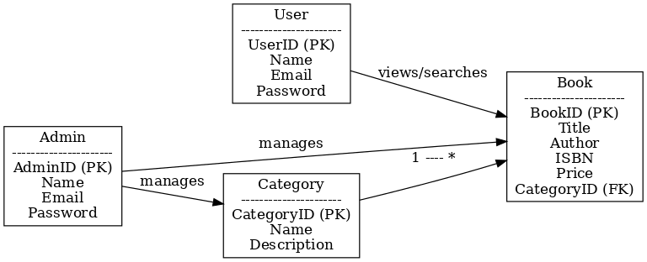

Figure 6.1 ER Diagram

The ER diagram associates the User, Book, Category, Contact, and Admin entities in order to have a strong system where:

- Users communicate with Books and send Contacts.
- Books have Categories and are uploaded by Users.
- Admin control Users, Books, and Categories while reading Contact messages.

Use Case Diagram
A use case diagram for the BookVault system graphically illustrates the application's functional requirements. It captures how various kinds of users (actors) use the system and makes the extent of provided functionality obvious. By depicting these interactions, the diagram makes it easy for stakeholders to get a top-level view of what the system does and how it helps its users.
In BookVault, there are two main actors:
- User (General Reader): Can register/login, browse and search for books, filter by categories, access free resources, mark favorites, and send questions through the contact form.
- Admin: Has higher privileges such as being able to manage books, users, and categories, in addition to viewing contact messages sent by users.
The system boundary is the BookVault Web Application that encompasses all use cases. This guarantees an easy distinction between which functionalities are managed inside the system and which are outside its boundaries.
Every use case is drawn as an oval, representing specific functionalities:
- For Users, some of the use cases are Register/Login, Browse Books, Search Books, Filter Books, Access Free Books, Add to Favorites, and Submit Contact Message.
- For Admin, use cases are Add/Update/Delete Books, Manage Categories, Manage Users, and View Contact Messages.
The associations are represented as solid lines connecting actors with their respective use cases. For example, the User actor is linked to the Search Books use case, indicating that users can conduct search operations. Likewise, the Admin actor is linked with the Manage Users use case, indicating administrative management of user accounts.
The diagram shows distinct role-based access: Users primarily engage with content consumption features, whereas Admin perform management and control features. This separation of duties provides both usability as well as system security.

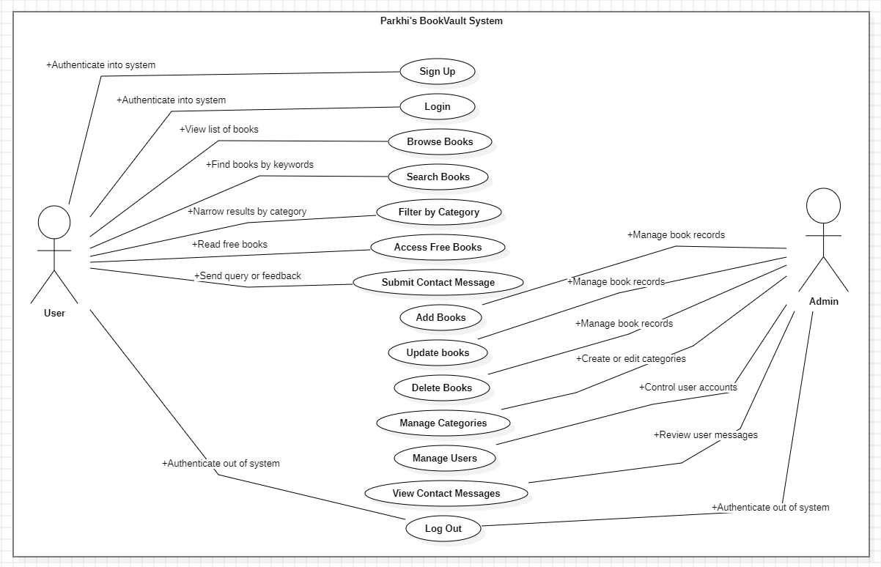

Figure 6.2 Use Case Diagram

6.4. Outputs

Figure 6.3 Home Page


Figure 6.4 Subscribe to BookVault

Figure 6.5 Explore Books


Figure 6.6 Responsive Footer


Figure 6.7 Sign Up Page

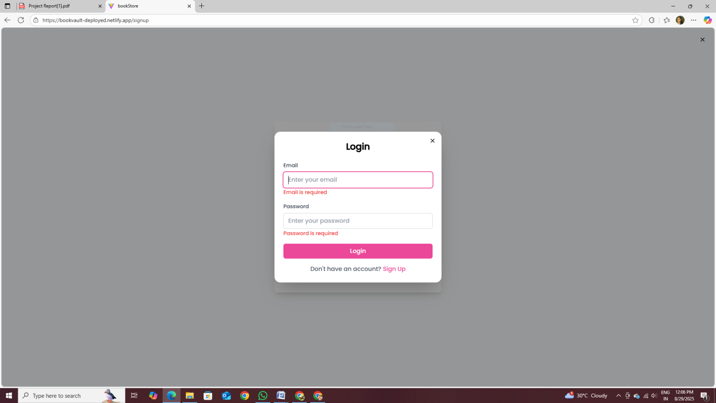

Figure 6.8: Login Page



Figure 6.9 Books’ Categories

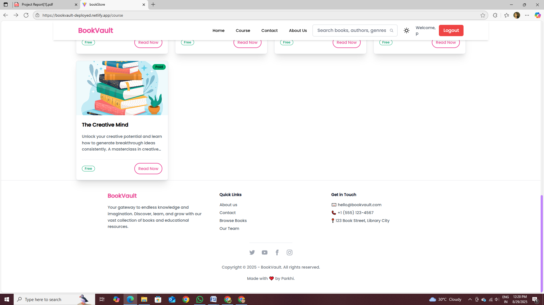

Figure 6.10 Course Page



Figure 6.11 Free Books



Figure 6.12 Reading Free Books



Figure 6.13 Buying Paid Books

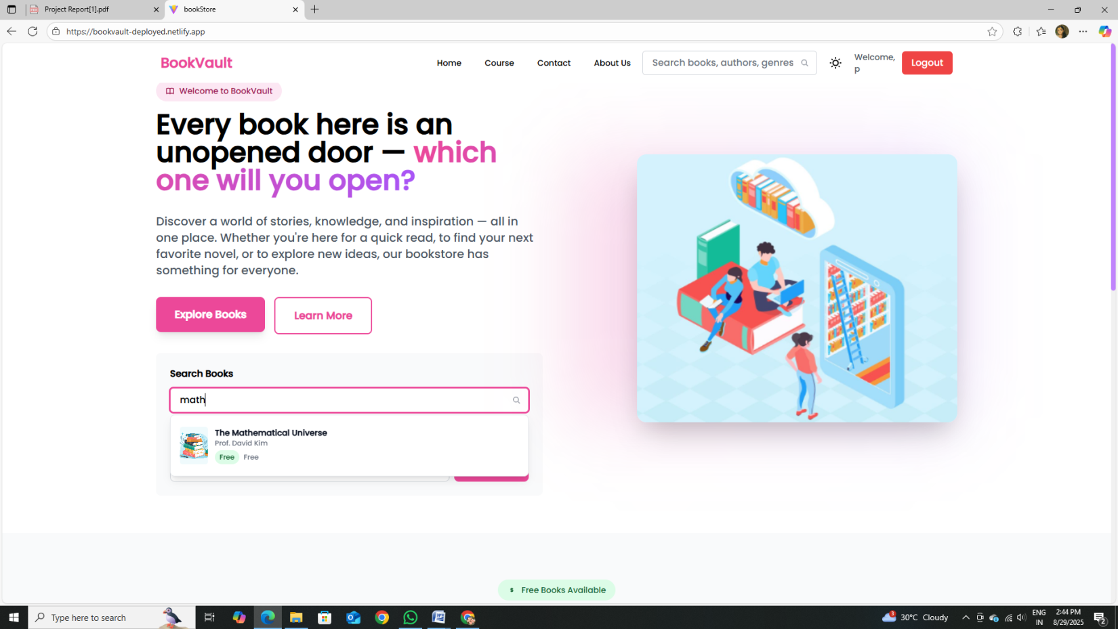

Figure 6.14 Search Books

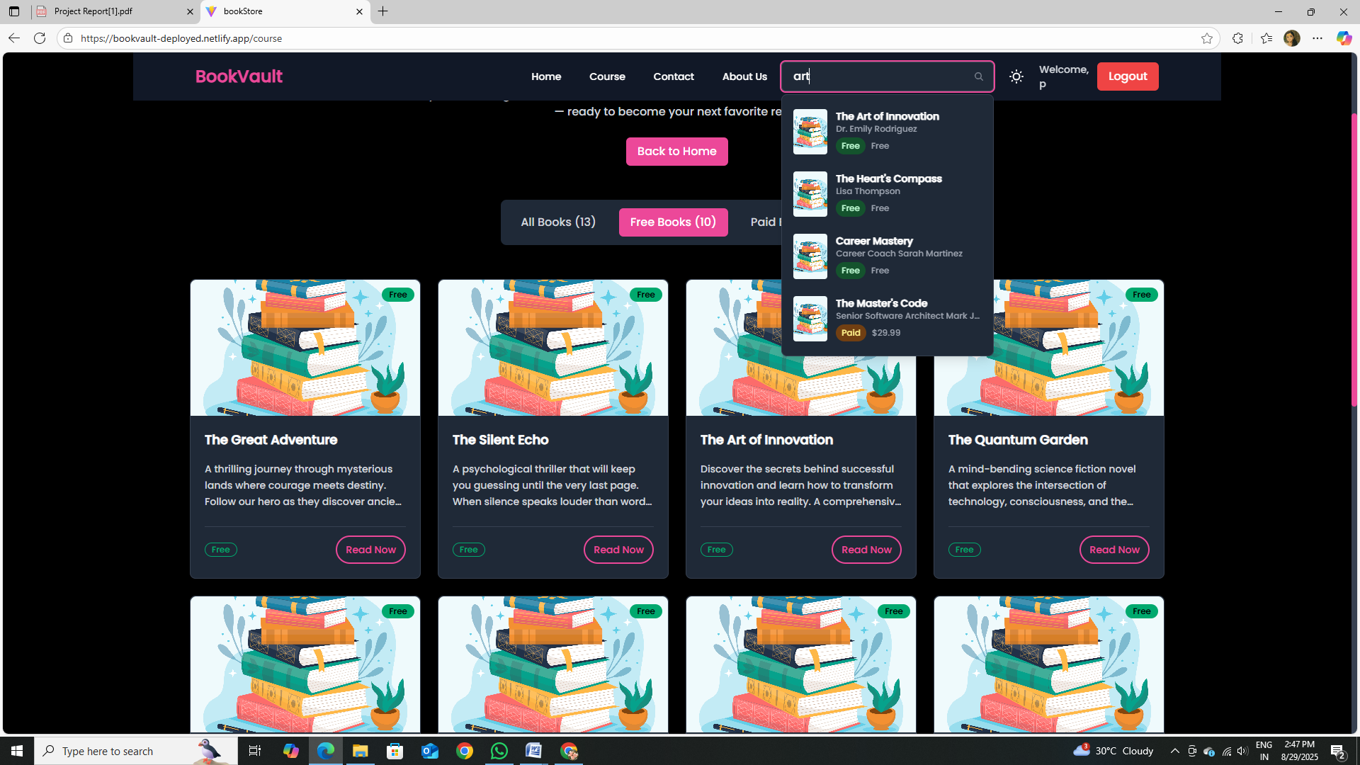

Figure 6.15 Dark Theme Available

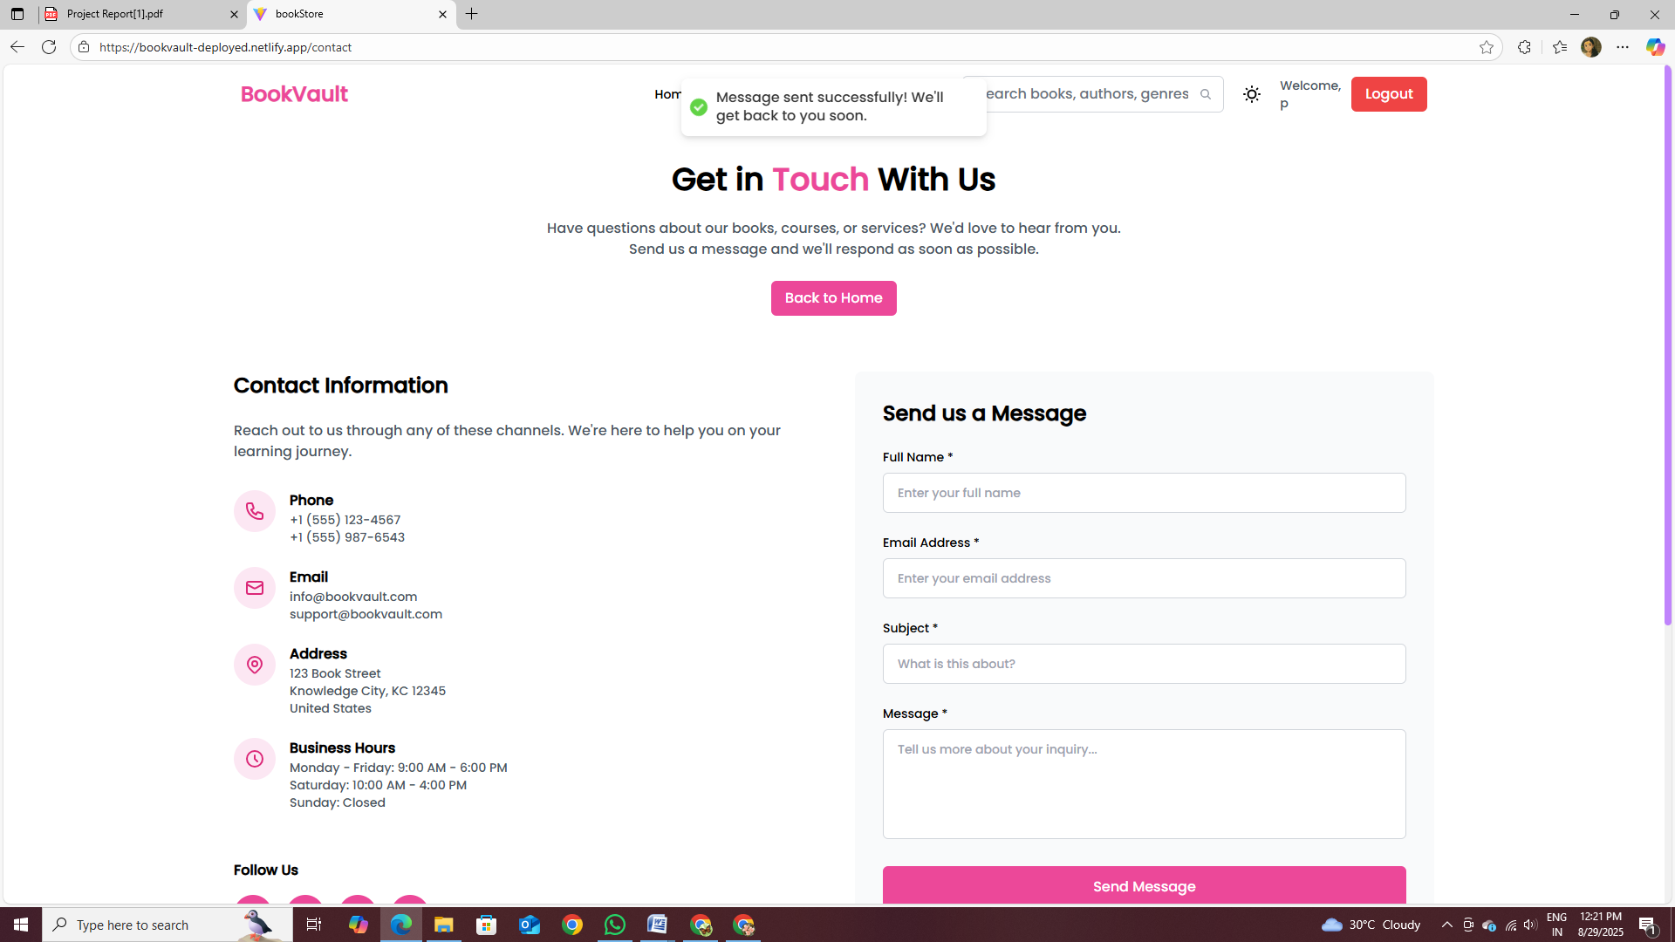

Figure 6.16 Contact Page

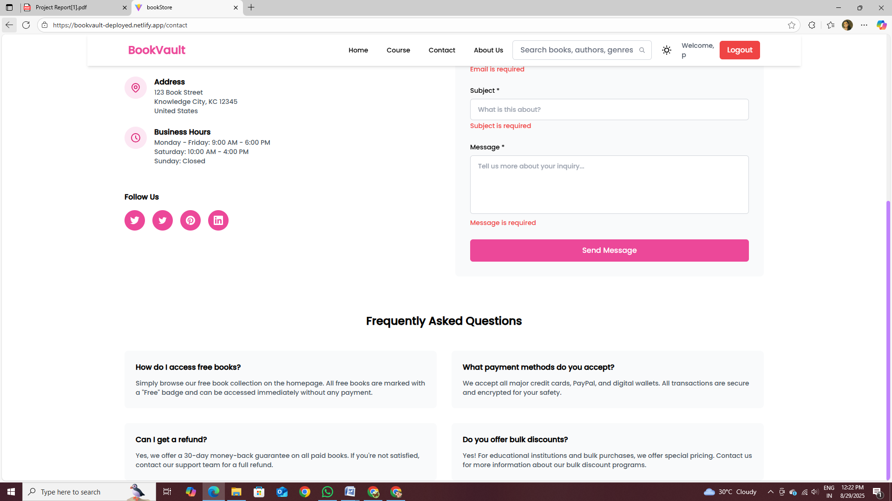

Figure 6.17 Frequent Queries About BookVault

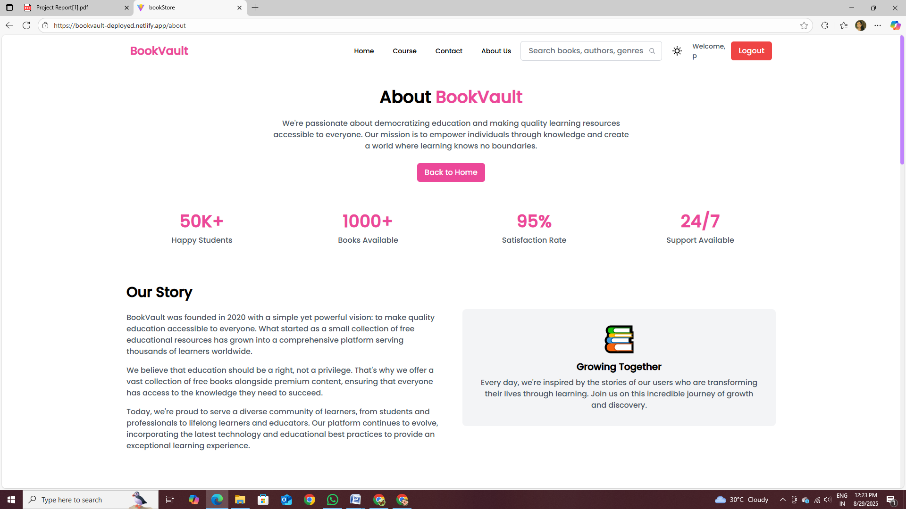

Figure 6.18 About Us Page

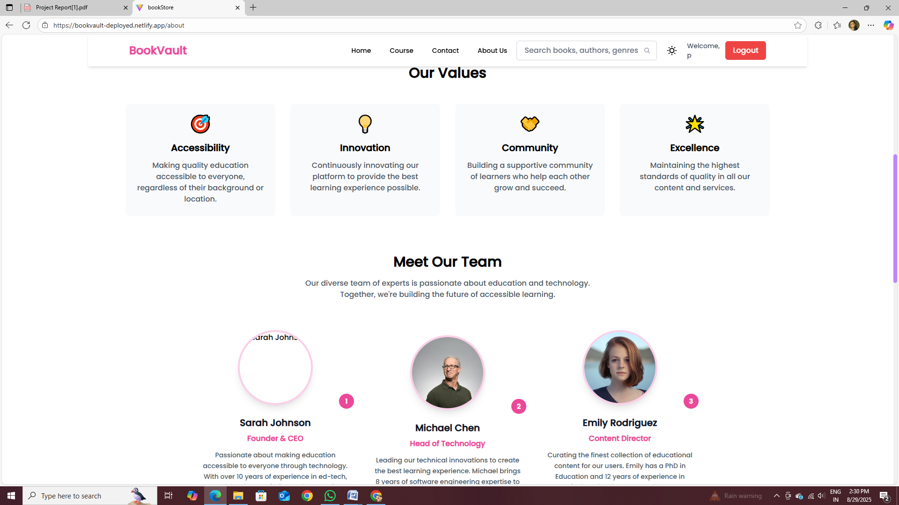

Figure 6.19 Our Team

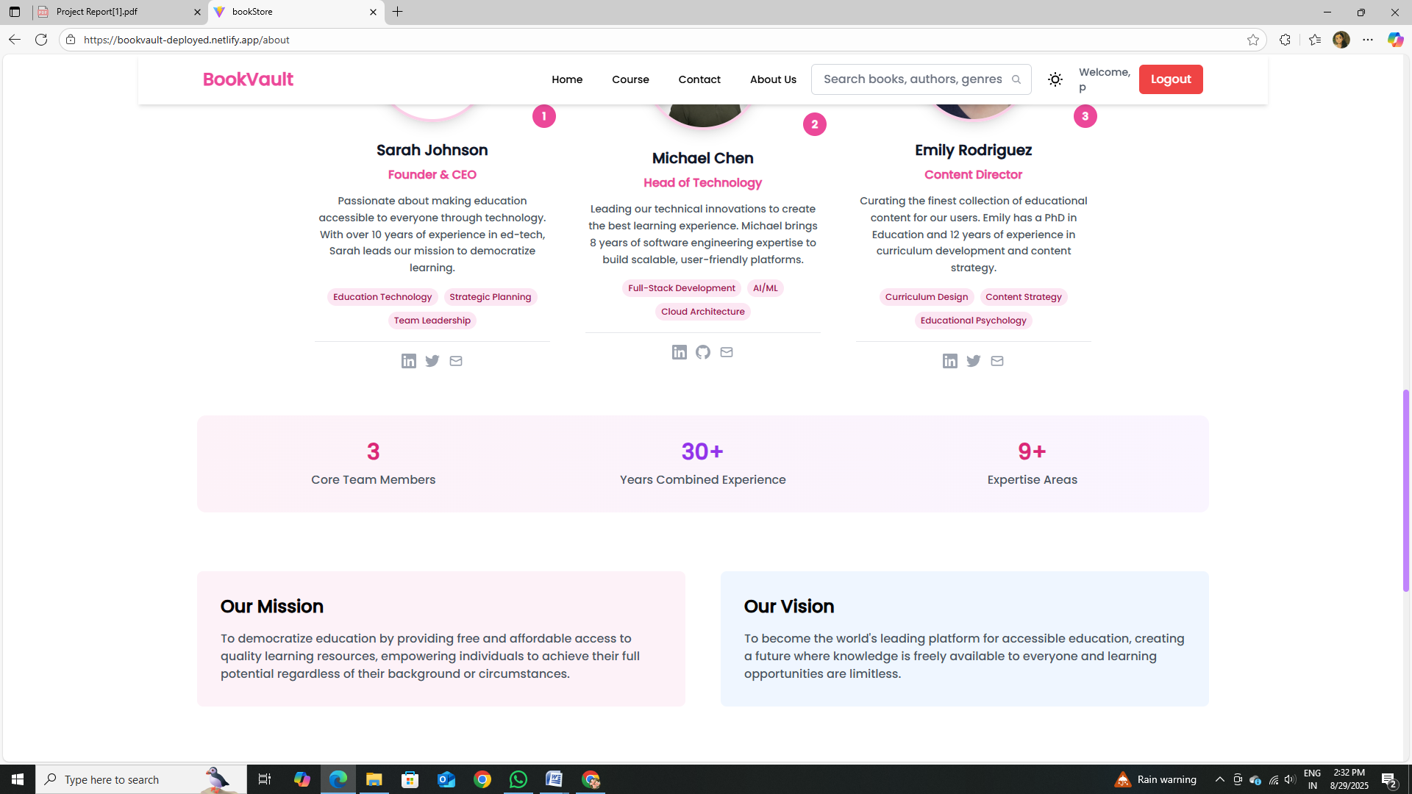

Figure 6.20 Mission & Vision of BookVault

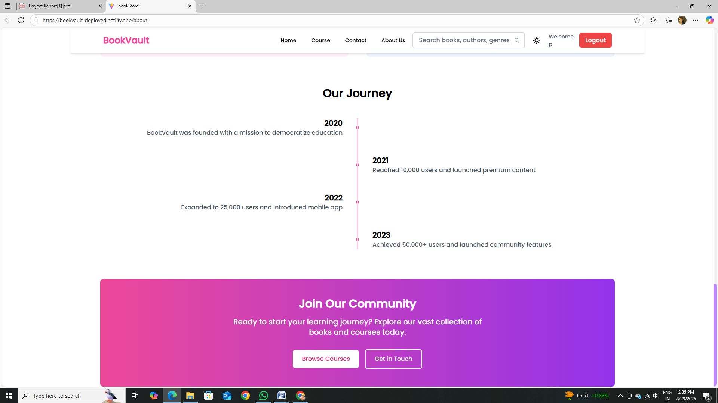

Figure 6.21 Our Journey

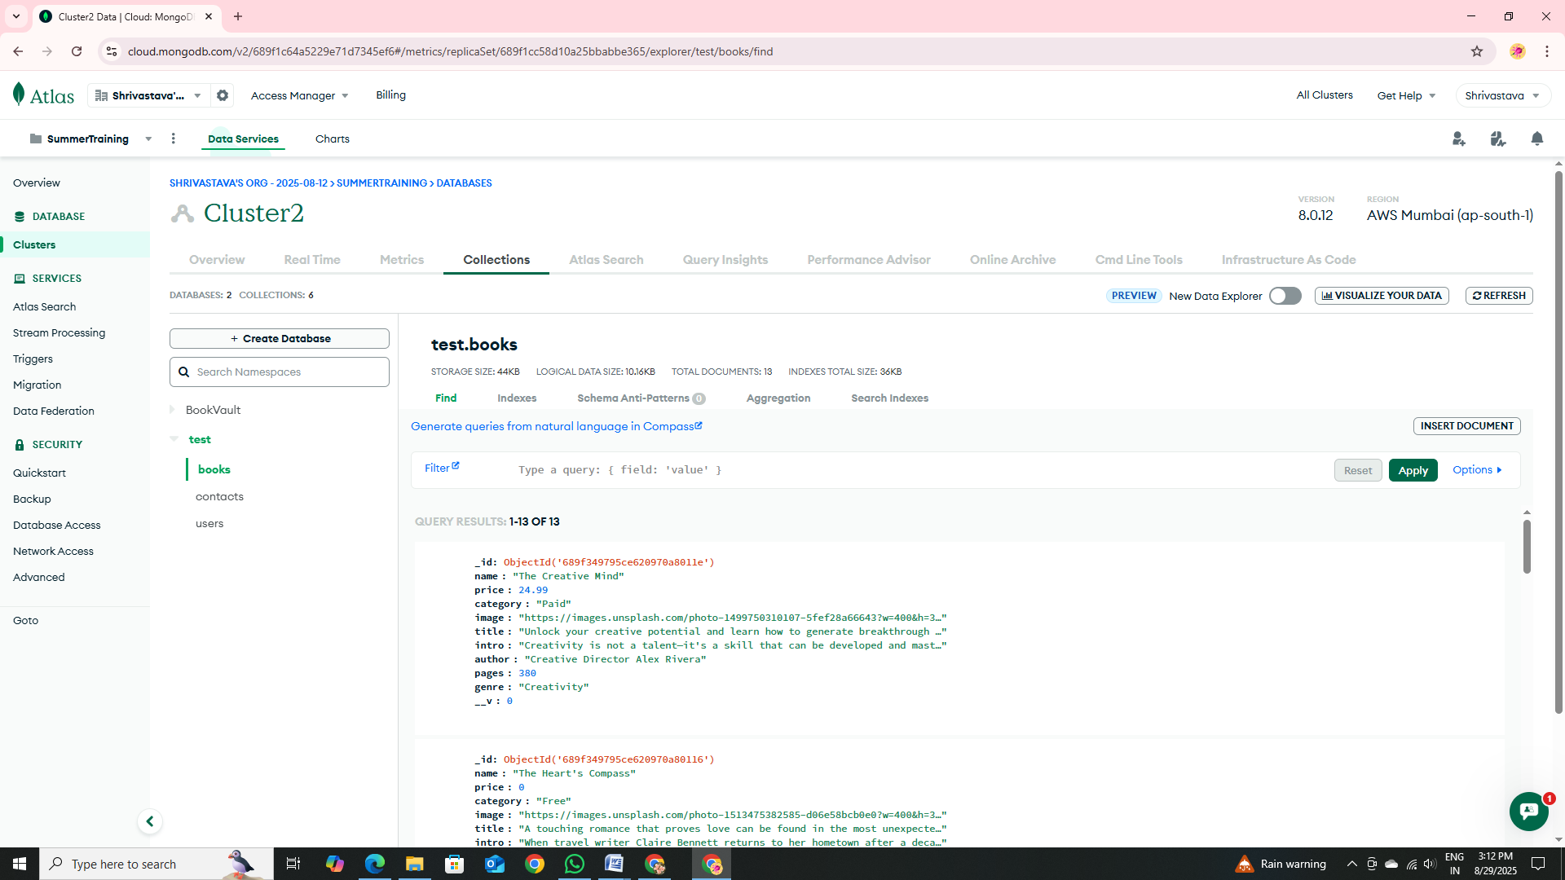

Figure 6.22 Books in Database

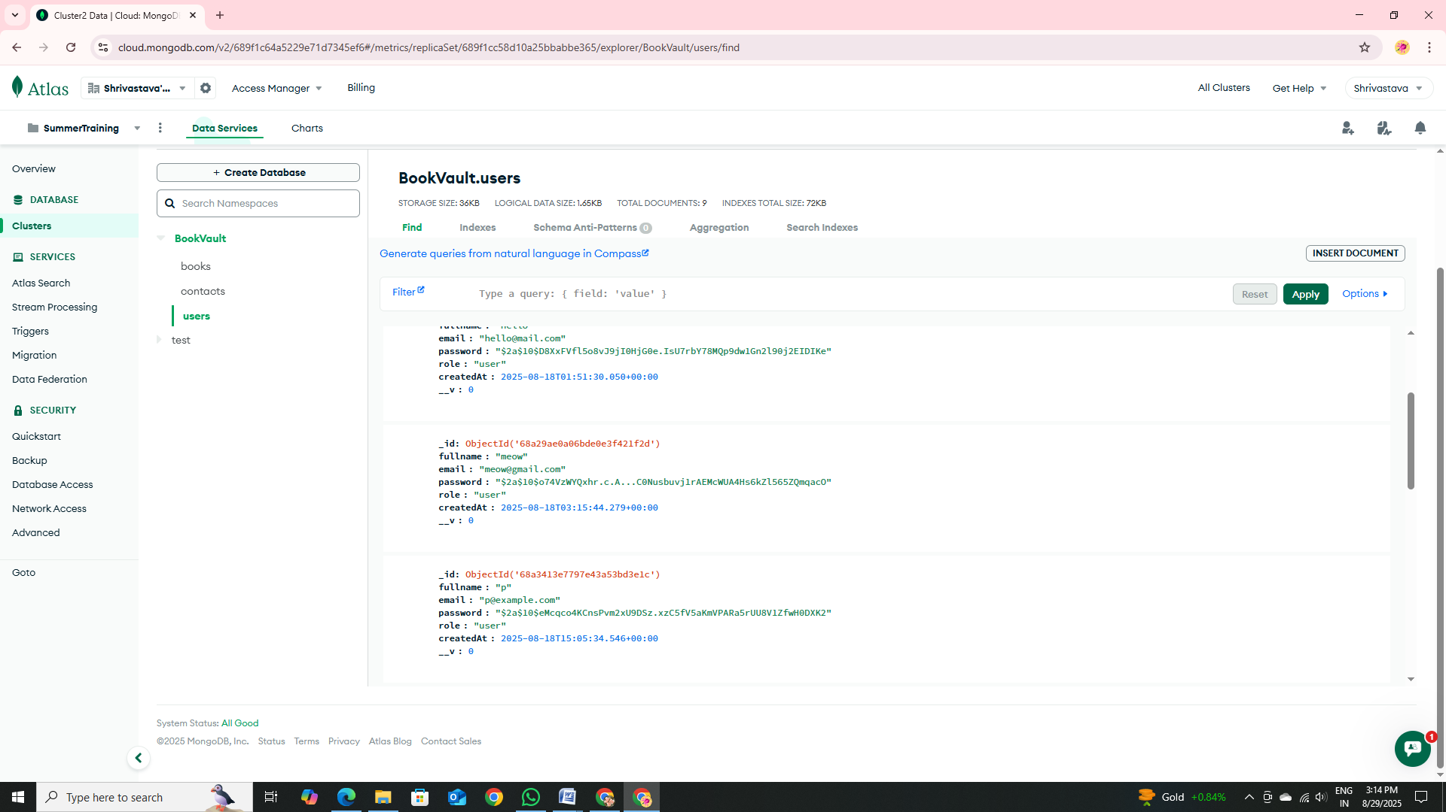

Figure 6.23 Users’ Login Info in Database

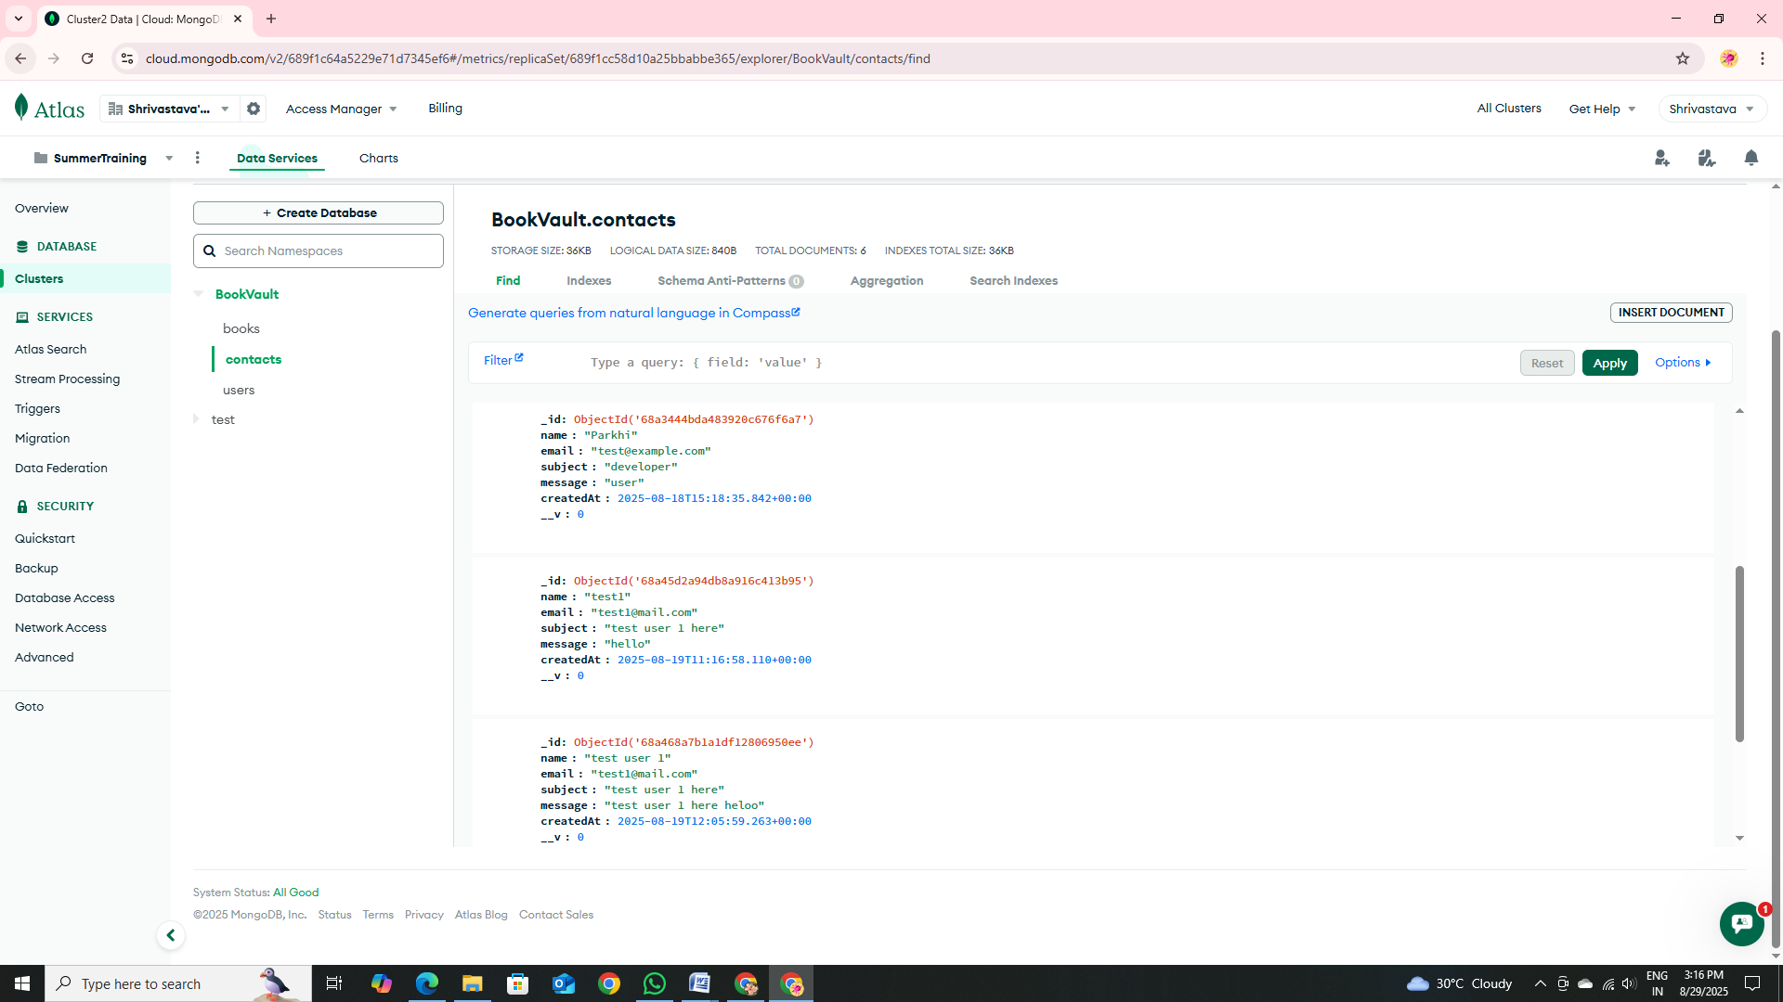

Figure 6.24 Queries Sent by Users in Database

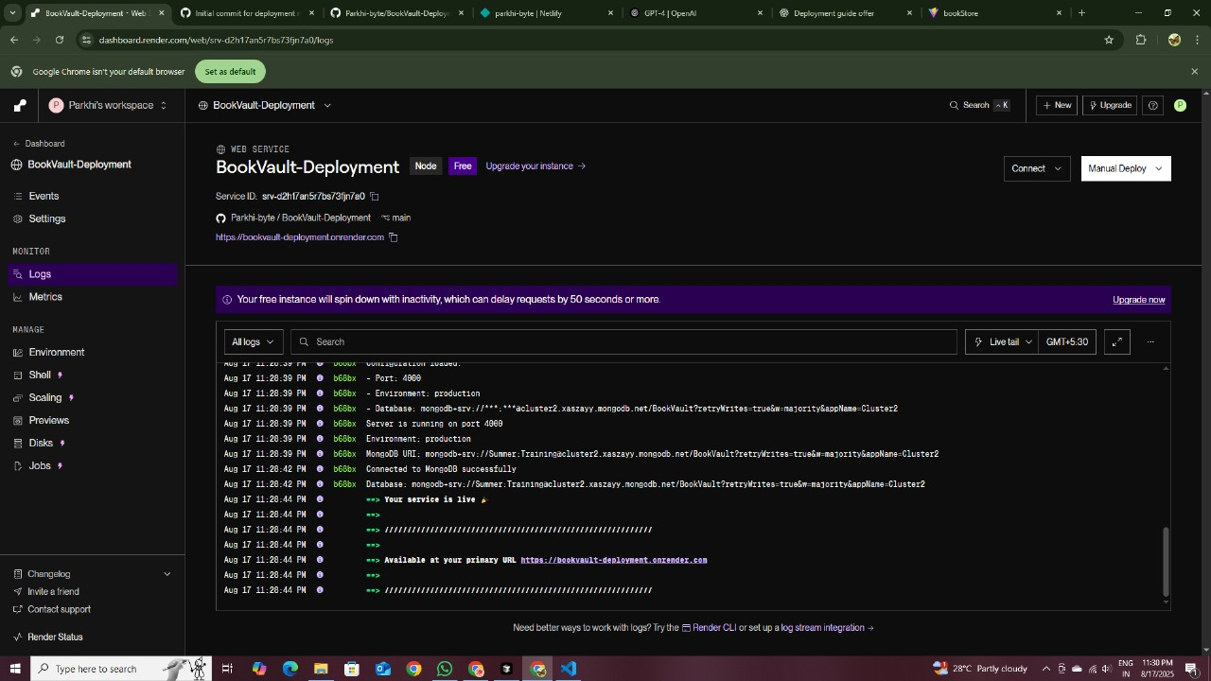

Figure 6.25 Backend Deployment



Figure 6.26 Frontend Deployment

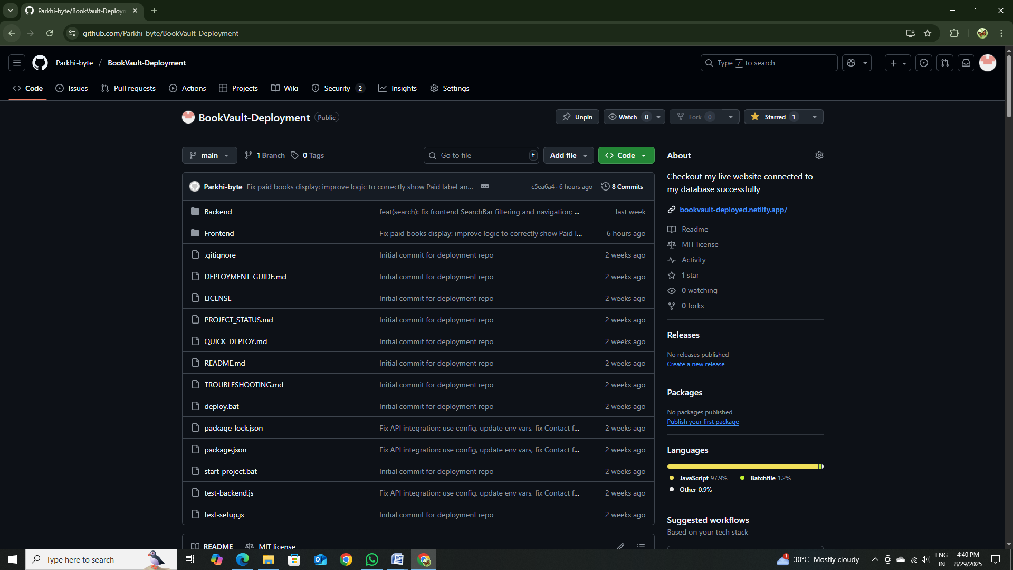

Figure 6.27 Git-Hub Repository

Chapter 7
Training Outcome

7.1. Introduction
During my industrial training at Techvision Technologies, I had the opportunity to work on BookVault, a modern full-stack bookstore application built with the MERN stack (MongoDB, Express.js, React, Node.js). In this chapter, I describe the outcomes of that training, highlighting the technical and professional skills I developed by designing, coding, and deploying BookVault. Unlike classroom exercises, my work involved real-world features such as secure user authentication using JSON Web Tokens (JWT), role-based access control, a responsive UI, and cloud deployment. These hands-on experiences gave me a practical understanding of web development in an industry setting.

7.2. Overview of Industrial Training

My training was immersive and project-based. I joined Techvision as a trainee full-stack developer, collaborating with a small team under the guidance of experienced mentors. From day one, we held planning meetings to outline the application’s requirements: features like free and paid book listings, user registration, and an admin dashboard. Each task was divided among team members, and I took responsibility for specific modules. On a daily basis, I participated in stand-up meetings where we tracked progress and discussed blockers. I got familiar with industry tools such as Postman for testing our Express API endpoints and setting up environment variables for different deployment stages. Overall, the training simulated a real development workflow: requirement analysis, architecture design, coding, testing, and deployment, all guided by mentors and paired with tangible deliverables (the fully functional BookVault app).

7.3. Skills Acquired During Training
Throughout this project, I acquired a broad set of technical and soft skills. Some key skills I developed include:
- Full-Stack Web Development (MERN): I gained hands-on experience with the MERN stack. On the front end, I created a React.js application using Vite for fast builds and hot reloading. I built React components (such as book cards and input forms) and managed state with hooks and the Context API for global state (like authentication status). On the back end, I set up an Express.js server with Node.js, connected to a MongoDB database using Mongoose, and defined schemas for books and users. I wrote server-side routes and controllers in Express to handle data requests. Working across front end and back end taught me how a full-stack application is structured and how data flows between React and the database.

- Authentication and Security: I implemented user login and signup with JSON Web Tokens (JWT) and password hashing using bcrypt. By storing JWTs on the client side (in memory or localStorage) and verifying them in Express middleware on the server side, I learned how stateless authentication works. I also set up role-based access control so that only admin users could access certain routes (for example, only users with an admin token could add or delete books). This taught me important security practices such as input validation, encryption, and protecting endpoints against unauthorized access.

- RESTful API Design and CRUD Operations: I designed and implemented RESTful API endpoints for managing books, users, and contact messages. For example, I created routes in Express like POST /api/books, GET /api/books/:id, PATCH /api/books/:id, and DELETE /api/books/:id to handle create, read, update, and delete (CRUD) operations. I tested these endpoints using Postman and consumed them in the React front end using the Fetch API or Axios. This experience solidified my understanding of how to design clear API routes and work with HTTP methods and status codes. I learned to handle asynchronous data exchange between the client and the server in a structured way.

- Front-End Development with Tailwind CSS: I used Tailwind CSS (along with DaisyUI components) for styling the user interface. Tailwind’s utility-first approach allowed me to apply styling directly in JSX classes, which sped up development by keeping me focused in the code editor. I built responsive layouts using Tailwind’s breakpoint classes (for example, configuring grid columns for mobile, tablet, and desktop). I also implemented a dark/light theme toggle using DaisyUI’s built-in theming. Working with Tailwind taught me how to build user interfaces efficiently and maintain a consistent design system across the components without writing a lot of custom Cascading Style Sheets (CSS).

- Version Control and Collaboration: I used Git for source control and hosted our code on GitHub. I practiced creating branches for new features or bug fixes, committing changes frequently with clear messages, and opening pull requests for review. By working in this way, I learned how to manage code collaboratively in a team. I experienced merge conflicts and resolved them by communicating with teammates and using tools like git merge and git rebase. The Git history served as a record of our project’s evolution and helped us revert changes when necessary. This taught me the importance of clear, frequent commits and collaborative coding practices.

- Deployment & DevOps: I learned to deploy a production-ready application. For the front end, I configured a build (npm run build) and deployed the React app to Netlify. For the back end, I deployed the Node/Express API on Render. This involved setting environment variables (such as the base API URL in Netlify and the MongoDB connection string and JWT secret in Render) and configuring the build commands. I also set up a MongoDB Atlas cluster for our production database. Through this process, I understood best practices in deployment, including how to host different parts of the stack on cloud services, manage environment-specific settings, and prepare our app for production use.

- Communication and Teamwork: I improved my soft skills by communicating regularly with team members and mentors. I participated in code reviews where teammates suggested improvements (for example, simplifying code logic or clarifying comments). I documented our API endpoints and wrote README files to explain how to set up and run the project. Using tools like Slack for quick questions and updates taught me how to synchronize work across a team. These experiences emphasized the importance of clear documentation and effective communication in a professional setting.

7.4. Practical Application of Skills
I applied all of the above skills directly in building BookVault. Some key examples include:
- Implementing Secure Authentication: I built a signup/login system using JWTs. In this flow, after a user logs in successfully, the server issues a JWT that encodes the user’s role (admin or regular). On the client side, I stored this token and attached it to API requests in the Authorization header. On the server side, I wrote Express middleware to verify incoming JWTs and to check user roles before allowing access to protected routes. For example, only when the token payload indicated an admin role could a user perform actions like adding or editing books. Debugging this flow (for instance, fixing issues with token formatting) reinforced my understanding of HTTP headers and authentication logic.

- Building CRUD Features: I developed full CRUD functionality for books (and users). In the React front end, users could browse and search the book catalog (read operations), and admins had forms to add new books or edit existing ones (create/update). On the back end, I defined Express routes connected to Mongoose models: for example, POST /api/books created a new book document, and PATCH /api/books/:id updated an existing book. I optimized some database queries by adding filtering and pagination for performance. This practical work taught me how to connect UI components to the database through the API and handle data flow end-to-end.

- Designing a Responsive Front-End with Tailwind: I used Tailwind CSS to style the UI. For example, I created a responsive grid of book “cards” that adjusted the number of columns based on screen size (using classes like md:grid-cols-2 and lg:grid-cols-3). I implemented a dark/light theme switch by leveraging DaisyUI’s theme utilities. Because Tailwind classes are inlined in JSX, I could quickly adjust margins, colors, and layouts without switching files. This hands-on styling experience taught me how to think in the terms of utility classes and also the breakpoints when building a user interface.

- API Integration and Testing: I wrote front-end services (using the Fetch API or Axios) that called the Express API endpoints. For example, when the home page loads, the front end fetches the book list via GET /api/books. Before integrating each feature, I tested the endpoint with Postman to ensure it returned the expected data or error. Through this process, I learned end-to-end debugging: using the browser’s developer tools to inspect network requests and console logs helped me trace issues between client and server.

- Version Control Workflow: In practice, I managed all code through our GitHub repository. For each feature or bug fix I worked on, I created a branch and made regular commits. After completing a feature, I opened a pull request so others could review my code. This workflow prevented loss of work: for example, if I accidentally introduced a bug, I could easily revert to a previous commit. I also experienced merge conflicts, which taught me how to resolve them carefully by communicating changes or rebasing when necessary.

- Deployment on Cloud Services: I deployed BookVault by connecting our GitHub repo to hosting services. When I pushed the front-end code to the main branch, Netlify automatically built and published the React app. I defined build commands and set REACT_APP_ environment variables (such as the base API URL). For the back end, I set up a Render service to run our Express server. In Render’s settings, I added environment variables like the MongoDB Atlas URI and the JWT secret key. This taught me real-world deployment processes and how to host different parts of the application on cloud platforms.

- Following Agile Practices: I used agile principles informally in our project. Before starting a feature, I estimated its complexity and set short milestones. After completing each feature, our team tested it and collected feedback from mentors. For example, after getting initial feedback on the search functionality, I improved the filters and UI iteratively. We also maintained a to-do list (using GitHub Issues or a task board) to prioritize work and track tasks. This iterative approach helped refine the app gradually and mimicked a real software development process.

7.5. Improved Understanding of MERN Stack Technologies
Working end-to-end on BookVault greatly deepened my understanding of each MERN component and how they work together. On the back end, I spent a lot of time writing Express routes and middleware, which taught me how to structure a Node.js server with clean, modular code. For example, I wrote a JWT verification middleware function that checked tokens before allowing access to protected routes. This exercise taught me about asynchronous processing in Node (using async/await) and the importance of middleware ordering. I also became more proficient with MongoDB and Mongoose: I designed schemas for entities (books, users, etc.), added validation rules, and learned to write queries for different operations. I optimized performance by adding indexes to speed up common searches and using .lean() for simple read queries.
On the front end, I learned advanced React patterns and tools. I built reusable components (such as a book card and input form components) which saved time when constructing the UI. I managed global application state for authentication and user information using React Context. By using React Router, I handled multiple pages (like the home page, a book detail page, and an admin dashboard) within a single-page app. Integrating Tailwind CSS into my React components reinforced a component-driven UI approach: each component’s style lived alongside its code. Working with these tools illustrated how a modern front-end framework coordinates with a back-end API and how data flows from the database to the displayed interface.
Overall, this project clarified the full-stack architecture for me. I learned how the Express server’s REST API acts as a bridge between the React client and the MongoDB database, with all layers using JSON as the data format. I also experienced the efficiencies of modern tooling: React’s fast development server (via Vite) made UI tweaks instantaneous, and Vite’s optimized bundling reduced load times. Concepts that were previously theoretical—such as REST principles, asynchronous JavaScript, and component-based design—became concrete through practice. This project-based approach greatly strengthened my fluency in MERN technologies.

7.6. Exposure to Industry Standards
During the project, I made a conscious effort to follow industry best practices and standards. Some examples include:
- Version Control and Code Reviews: I used Git/GitHub as our centralized code repository. I practiced writing clear commit messages and creating pull requests for each feature. The code review process taught me to write maintainable, clean code and follow a consistent style (we agreed on formatting rules and linting to keep the codebase readable). Seeing teammates’ feedback during reviews emphasized the importance of code quality and readability.

- Secure Configuration: I never hardcoded sensitive values in the code. Instead, I used environment variables to store configuration settings like database URIs, API keys, and the JWT secret. For example, on Render I added the MongoDB Atlas URI and JWT secret in the environment settings rather than checking them into source control. This aligns with security best practices for different deployment stages and helps prevent accidental leaks of secrets.

- Error Handling and Validation: In our Express routes, I implemented proper error handling by sending meaningful HTTP status codes and messages (e.g. 400 for bad input or 500 for server errors). I also added server-side validation using Mongoose schemas and custom checks to guard against invalid data. On the client side, I included form validation to prevent users from submitting incorrect or incomplete information. These practices helped me appreciate robustness and reliability in real applications.

- Responsive and Accessible Design: Using Tailwind, I followed a mobile-first approach: I designed UIs that adapt fluidly to various screen sizes by using responsive utility classes. I also paid attention to accessibility – for instance, I added descriptive alt text for images and ensured sufficient color contrast in both light and dark modes. Techvision emphasizes UI/UX quality, so I made sure to consider the end-user by testing the site on different devices and browsers.

- API and Data Standards: I structured our REST APIs with clear endpoints and consistent JSON responses. For example, every API response used a standard format (including success/error flags and messages) to make it predictable for the front end. I also configured CORS properly in Express so that our front-end domain was allowed to call the API, reflecting security measures used in real-world services.

- Testing and Quality Assurance: Although we did not have time for formal unit tests, I performed manual testing for each feature. I followed a checklist to verify functionality such as the login flow, search, and CRUD operations on multiple devices. Additionally, automated deploys (Netlify builds on push and Render redeploys) gave me a sense of continuous integration: every time we pushed code, the updated app was automatically built and deployed.
Exposure to these industry conventions and practices—from version control and configuration management to responsive design and testing—prepared me for professional software engineering. I learned that building production-grade software involves more than writing code; it also requires attention to security, user experience, and maintainability at every step.

7.7. Personal Reflections on Real-World Software Development
This industrial training bridged the gap between academic projects and real-world software development for me. Unlike guided exercises in school, the BookVault project had open-ended requirements and higher quality expectations. I learned to adapt when requirements evolved: for example, after presenting the first prototype, our mentor requested enhancements to the search filters and additional UI polish. Accommodating these changes taught me flexibility and the importance of iterative improvement.
I also experienced concerns beyond just core functionality. For instance, deploying an application made me think about uptime and security. I set up a simple health-check endpoint (/health) on the back end so that a monitoring tool could verify the service was running. We discussed scaling considerations as well, such as how MongoDB Atlas uses replica sets for high availability. These aspects (service monitoring, scaling) are typically not covered in classroom assignments.
Furthermore, I saw how user experience matters in a production context. Ensuring fast load times and intuitive navigation became priorities. Mentor feedback (acting as a user) highlighted the importance of small details, like clear error messages on invalid login attempts. This real-world focus on the complete product (not just code correctness) was eye-opening.
In summary, this training immersed me in the full software development lifecycle: requirement analysis, planning, development, testing, deployment, and maintenance. This was a valuable contrast to most academic projects, which often end at implementation. I now have a fuller understanding of what it means to build software that is robust, secure, and user-friendly in a real production context.

7.8. Project and Time Management Experience
Working on BookVault also improved my project and time management skills. I learned to break down the project into modules and set clear priorities. For example, I identified core features (authentication and basic CRUD operations) as the critical path and implemented those first, ensuring the app had basic functionality before adding secondary features. This approach kept the project on track.
I used task-tracking tools (such as GitHub Issues) to list tasks and assign responsibilities (even though I was mostly working individually, the structure mirrored a team project). Setting deadlines for tasks helped create accountability. I found that I initially underestimated how long some features would take. For instance, integrating Tailwind CSS and custom theming took longer than expected. In response, I started allocating extra buffer time for unfamiliar tasks. This taught me the importance of realistic time estimation in professional work.
Since this project was also a learning exercise, I had to balance research with coding. I practiced timeboxing: I would spend a set amount of time researching a new concept or tool, then focus on implementing what I learned. This prevented me from getting stuck in endless analysis and helped me meet our weekly goals. Regular reviews were scheduled by our mentors, and I had to deliver working demos by those deadlines. For example, I set an internal goal to complete the admin dashboard a week before the actual demo day, leaving time for testing and bug fixes. Meeting these deadlines gave me confidence and reinforced a sense of professional discipline.
Overall, running this small-scale project helped me develop essential planning and scheduling skills. I saw firsthand how setting clear goals, maintaining an organized workflow, and dedicating consistent effort lead to successful project completion. These project management skills are just as important as the technical ones I learned, and they will guide me in my future software development work.

Chapter 8
Conclusion & Future Scope

8.1. Conclusion
During my industrial training at Techvision Technologies, I developed BookVault entirely on my own, which has been an invaluable learning experience. As the sole developer, I applied the full MERN stack (MongoDB, Express.js, React.js, Node.js) to create a comprehensive book management system. I successfully implemented key functionalities, including secure user authentication using JSON Web Tokens and role-based access control for admins and regular users. I also designed and built all CRUD (Create, Read, Update, Delete) operations through RESTful APIs, created a responsive UI with React.js and Tailwind CSS, and managed data storage with MongoDB. Finally, I deployed the project by hosting the front-end on Netlify and the back-end on Render.
Working independently on this project sharpened my problem-solving and debugging skills. I gained hands-on experience in clean coding practices and database management. Using Git and GitHub for version control taught me the importance of maintaining code history and collaboration workflows, even when working solo. Most importantly, this project bridged the gap between theory and practice for me. Completing BookVault from start to finish under my own initiative proved that I can design, develop, and deploy a full-stack application on my own, boosting my confidence in tackling real-world challenges.

8.2. Future Scope
8.2.1. Personalized User Dashboard
Building a personalized dashboard will let each user manage their profile and favorite collections. For example, library platforms often include a “My Account” area where users can save items, view history, and organize projects. Allowing users to curate their own “bookshelves” or reading lists encourages engagement – studies show that user-curated collections help audiences connect more deeply with digital content. In practice, the dashboard could include profile settings, a list of bookmarked titles or shelves, and perhaps personalized reading statistics. This personal space not only improves usability (letting users easily resume or repeat past searches and checkouts) but also fosters loyalty by giving users a sense of ownership over their reading journey.

8.2.2. Search Optimization and AI Recommendations
Enhancing the search function with rich filters and smart suggestions will make it much easier for users to find relevant books. We should implement faceted filters (e.g. by author, genre, publication date, language, or rating) so users can narrow results quickly. Beyond simple filters, adding an AI-driven recommender can suggest books based on a user’s interests or reading history.
For instance, recent research notes that AI techniques like natural language processing and machine learning help interpret vague or complex queries and improve relevance of results. In fact, OCLC’s WorldCat has begun beta-testing an AI-powered recommendation engine: users searching for a title now get automatic suggestions of related print and e-books. By combining advanced search filters with such AI recommendations, BookVault can both help users drill down to precise results and discover new books they might not otherwise find.
- Advanced filters: E.g. allow filtering by genre, author, year, language, format, etc., enabling faceted search.
- AI-powered suggestions: Use ML/NLP to analyze user input or history. As one study observes, NLP/ML can “enhance comprehension of queries, contextual understanding, and relevance of the results” in a digital library.
- Examples in practice: Many modern library systems and online bookstores (e.g. WorldCat Find) use AI to suggest related titles or subjects without exposing user data.

8.2.3. Mobile Application (React Native)
Developing a mobile app for BookVault will make the library accessible anywhere, anytime. With over 60% of internet users browsing on mobile devices (and even higher in many countries), providing native apps on iOS and Android is key for user engagement. Using React Native lets us build one codebase that runs on both platforms, greatly saving time and cost compared to separate native apps.
For example, large companies like Facebook and Airbnb use React Native to maintain a single codebase for iOS and Android, reusing over 90% of their code. In practice, the app could feature offline reading (caching downloaded books), push notifications for new releases, and use device features (e.g. a reading timer).
Benefits: A cross-platform mobile app increases adoption (most users prefer app convenience), and React Native’s community support and hot-reloading speeds up development.

8.2.4. Payment Gateway Integration
Enabling secure online payments will allow users to buy or rent books directly. We can integrate trusted payment providers (such as Stripe or PayPal) via their APIs. For example, Bookshop.org – a platform for independent bookstores – uses Stripe to process millions of book purchases with built-in fraud protection. Stripe (or similar) handles credit/debit cards, digital wallets, multiple currencies, and PCI compliance, so BookVault can accept payments with minimal hassle. The checkout workflow might include a shopping cart or one-click purchase, with HTTPS encryption and tokenized payment data.
Benefits: Users enjoy the convenience of instant purchase without leaving the platform. At the same time, using a mature gateway ensures transactions are secure (TLS, CVV checks, etc.) and reduces risk for BookVault. It also opens revenue possibilities (selling e-books or print copies). As a case study shows, Bookshop.org saw 36% higher mobile conversions after adding a modern payment solution, suggesting e-commerce can significantly boost engagement and sales.

8.2.5. Cloud Scalability (MongoDB Atlas)
Migrating our database to a managed cloud service like MongoDB Atlas will greatly improve scalability and uptime. Atlas provides multi-node clusters with automated replica sets for high availability. In MongoDB’s own documentation, “a replica set is designed for high availability and redundancy” – meaning if one node fails, others keep the data online. Atlas also offers automated backups and multi-region deployment, so the service stays up even if a server or datacenter goes down. Importantly, Atlas supports both vertical and horizontal scaling built-in. As MongoDB notes, it has “a full range of vertical, horizontal, and elastic scaling options… built into MongoDB Atlas”.
In practice, we could start with a small instance and enable auto-scaling so that as traffic grows (more users, more books), Atlas automatically allocates more CPU, RAM or adds shards. This ensures BookVault remains responsive under heavy load (such as when a popular title is released) without manual intervention.
Benefits: Cloud clustering means near-100% availability and faster query performance (thanks to sharding and read replicas), and it offloads infrastructure management to Atlas’s managed service, freeing our team from routine DBA tasks.

8.2.6. Enhanced Security (MFA & Role Management)
Strengthening security is crucial as BookVault grows. We should implement multi-factor authentication (MFA) so that user logins require a second factor (like an SMS/email code or an authenticator app) in addition to a password. Industry guidance explains that MFA “requires a user to verify their identity by providing more than just a username and password” – for example, combining something you know (password) with something you have (security key or phone). By adding this extra layer, compromised passwords alone are no longer enough for attackers to breach accounts.
Additionally, we should enforce role-based access control (RBAC) on the backend. RBAC means defining roles (e.g. admin, librarian, patron) with the minimal permissions needed. As IBM notes, RBAC “enforce[s] the principle of least privilege,” ensuring users can only access the data and functions their role requires. For example, regular users cannot delete books or view other users’ data; librarians might manage the catalog but not internal logs, and admins have full control. This limits damage from both external attacks and insider errors. Together, MFA and strict RBAC will help protect BookVault’s accounts and data as it scales, aligning with security best practices and compliance requirements.
- Multi-factor authentication: Require an additional factor (SMS, email code or authenticator app) on login. This mitigates credential theft, since attackers would also need that second factor.
- Role-based access control: Define roles (e.g. admin, content manager, user) with specific permissions. Restrict each account to only its necessary privileges (the least privilege principle). This prevents normal users from accessing admin functions and reduces insider threats.

8.2.7. CI/CD Pipeline Automation
We should adopt Continuous Integration/Continuous Deployment pipelines to automate testing and releases. With a CI/CD setup (for example using GitHub Actions or Jenkins), every code commit or pull request automatically triggers a build and a suite of automated tests. This ensures that bugs are caught early: as Red Hat explains, CI builds and runs unit/integration tests on each merge so that conflicts or errors are detected immediately.
For BookVault, we could configure a workflow where merging code into the main branch runs linting, tests, and then deploys to a staging server. Using GitHub Actions (a popular CI/CD platform) allows writing YAML workflows that build and test code on Linux/Windows machines whenever code is pushed.
Benefits: Automated pipelines reduce manual errors, enforce coding standards, and greatly speed up release cycles. Instead of manually running tests and deployment scripts, the CI/CD system does it on every change. This not only makes releases more reliable, it also frees developers to focus on features. Over time, a robust CI/CD process will streamline future development and encourage practices like trunk-based development and faster iterations.

8.2.8. Analytics & Insights Dashboard
Providing data-driven dashboards will help administrators monitor and improve the platform. We can collect metrics such as number of daily active users, top-searched titles, most downloaded books, or average session length. Visual dashboards (e.g. with charts and tables) can present these KPIs in real time. The value of this is well-documented in library operations: data analysis lets staff “build services and offerings based on proven demand” rather than guesswork.
For instance, a dashboard might show that certain genres see spikes at exam season, or identify underused resources. Librarians have found that having “real-time insights based on data from library systems” empowers better decisions. In practice, we could implement an admin panel using tools like Chart.js or Grafana connected to our database or logs. This admin dashboard would help BookVault’s team track key metrics (e.g. new sign-ups per month, search-to-checkout conversion rates) and spot issues early (e.g. a sudden drop in usage). Ultimately, these analytics will make the platform more responsive: by understanding how users actually interact with BookVault, we can refine collections, fix pain points, and demonstrate the platform’s impact to stakeholders.
By implementing these enhancements, BookVault will become a more scalable, secure, and user-centric digital library. Each improvement addresses a critical area: personalization and search refinements make the interface more engaging, mobile and payment features expand access and monetization, cloud clustering ensures reliability, security measures protect user data, CI/CD streamlines development, and analytics enable data-driven decisions. Together, these changes would transform BookVault into a robust platform well-suited for academic research and professional library needs, helping users find and use books efficiently while keeping the system maintainable and secure.

References

- Books and Articles:
- "Clean Code: A Handbook of Agile Software Craftsmanship" by Robert C. Martin
- "Eloquent JavaScript: A Modern Introduction to Programming" by Marijn Haverbeke

- Web Resources:
- React Js Documentation: https://reactjs.org/docs/getting-started.html
- Node.js Documentation: https://nodejs.org/en/docs/
- Express.js Documentation: https://expressjs.com/
- ER Diagram Design: https://www.mermaidchart.com/app/projects/39a41d94-b616-41b1-8a32-1aea609e835f/diagrams/2d023022-f8f5-4713-9fe1- 13ab3904a707/version/v0.1/edit

- Industry Standards:
- IEEE Standards Association. (1998). IEEE Std 830-1998: IEEE Recommended Practice for Software Requirements Specifications. IEEE.
- ISO/IEC 9126. (2001). Software Engineering - Product Quality. International Organization for Standardization.

- Tools and Platforms:
- GitHub: https://github.com/
- https//www.Techvision Technologies.com/technology/react-js-training/course
- Tech Vision Technologies: https://techvisiontechnologies.com/
- https//www.Techvision Technologies.com/hr.consultancy#
- https//onlinetraining.Techvision Technologies.com/login.aspx?ReturnUrl=%2fstudents%2faplyonlinetraining.aspx
- https//onlinetraining.Techvision Technologies.com/students/RequestforCertificate.aspx
- Citations:
- CADD MENTOR & TECH VISION TECHNOLOGIES in Rampur Garden,Bareilly - Best CAD Training Institutes near me in Bareilly - Justdial
- https://www.justdial.com/Bareilly/CADD-MENTOR-TECH-VISION-TECHNOLOGIES-Near-Uttam-Public-School-Opposite-Agarsen-Park-Rampur-Garden/9999PX581-X581-110604140726-I2B1_BZDET

